

**MENNAISIAN NOVENA**

**AUGUST 2024**

1. **POSTULATION NEWS**

We need Fervent Prayers for:

- Ask the Doctors in Argentina who took care of the Hospitalization of little Enzo, so that they can still contribute to providing Additional Information that could help advance The Cause

- Help the 4 Specialist Doctors who are in the process of writing a New Expert Opinion on the Enzo Carollo Healing, so that they are inspired to find the elements which can prove the Inexplicability of the Healing.

1. **RECOMMENDED PRAYER INTENTIONS TO THE FATHER**

We always pray for the Children whom we have Recommended to the Intercession of the Father:

* ***Augustin German***: affected by Osteosarcoma.

* ***Tommaso Leonetti***: Digestive System Incident, on the mend.

* ***Greta***: little girl suffering from Cerebral Glioma, still fighting for her life.

- Let us continue the prayer for the complete healing of ***Brother Alain Josselin***

- Let's add a conversion of the ***young CC*** currently in prison and the healing of ***Liliana***, Mother of 6 children, suffering from Pancreatic Cancer

1. **FAVORS RECEIVED THROUGH THE INTERCESSION OF THE FATHER**

Bro. Natalis-Joseph Savatte relates the following story, which happened to him when he was Assistant and at the same time Visitor of the Brothers of Ille-et-Vilaine and Morbihan, in the 1930s.

*“Mrs Jeuland, from Torcé near Vitré, sister of CF Crémence, who died in Ploërmel in 1900, and mother of one of our current Brothers, recently entered a Clinic in Rennes for an Acute Attack of Appendicitis. The Operation took place simply. I went to his bedside two days later. She could barely recognize me and only uttered a few words: Pulmonary Congestion had just started. Her condition was alarming and the Nurse Sister did not hide it from me.*

*At that moment, I told the sick woman and her family gathered, anxious, near her, that I was going to ask the Community of Jersey for a Novena to the Venerable Father de la Mennais. Then I was told that a Relic Image of the Servant of God had just been slipped under the pillow Image loaned the previous year for another patient and found accidentally the day before. When I returned to the Clinic a few days later, I was happily surprised to find Ms. Jeuland out of danger. She told me that, since the beginning of the Novena, she had the impression of having, next to her, Father de la Mennais and Brother Crémence, both watching over her.*

*The Congestion had disappeared and the dressings, so painful before, were done without her feeling any suffering... Convalescence took place in the best conditions; and, some time later, Madame Jeuland, accompanied by all her family, went to Ploërmel, to the Tomb of the Venerable, on a Pilgrimage of Thanksgiving. A large Portrait of V. Jean-Marie de la Mennais has since adorned the Dining Room of the Jeuland Family.*

*Br. Natalis-Joseph”*

SOURCES : COLLECTION OF BR JEAN-CHARLES BERTRAND, FIC ROME ARCHIVES

1. **DEVOTION TO THE FATHER :**

**THE FIRST EXHUMATION AND TRANSLATION OF THE FATHER'S MORTAL REMAINS TO THE CHAPEL OF THE MOTHERHOUSE IN PLOERMEL**

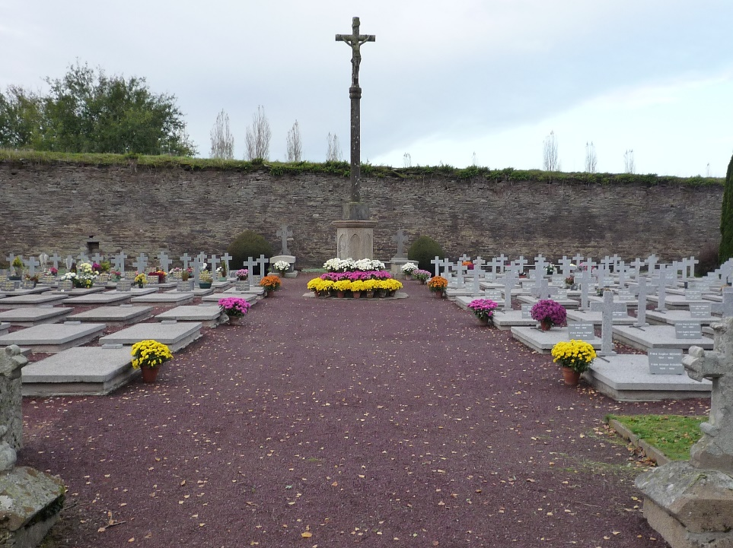This year, 2024, the Mother House of Ploërmel is celebrating the Second Centenary of its Foundation: A long History of Constructions and Spirituality, of Formation and Prayer, of Impulses and Persecutions, of Ordinary Life and Extraordinary Achievements. It is the Center of the History of an Institute of Brothers who have the Mission of making Jesus known through the Christian School. The Heart of Ploërmel has always been Father de la Mennais, united with his great friend and collaborator, Father Deshayes. He was during his life, but he still is, now also after his death. He is present with his Mortal Remains, a sign of his Paternal Presence.

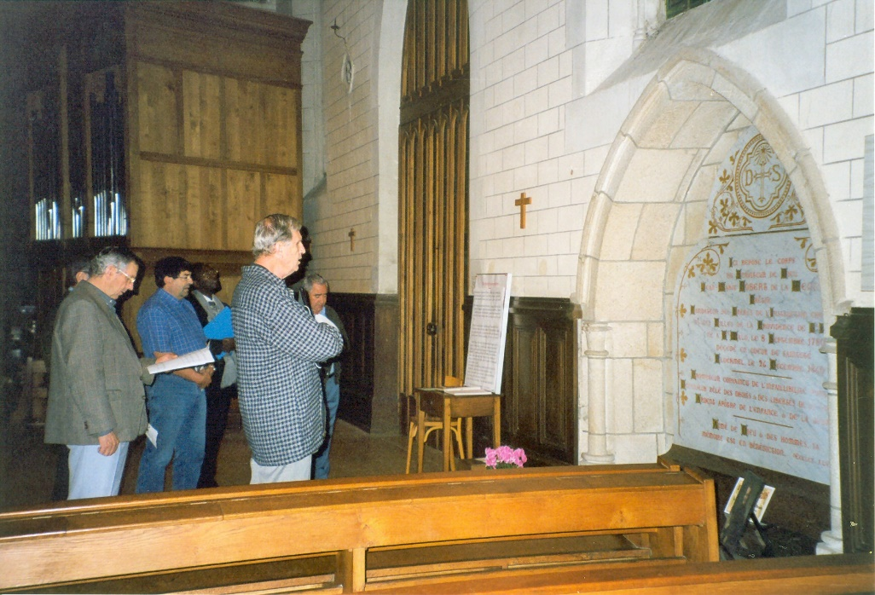In fact, he had expressed his desire to rest in the peace of God among his little Brothers in the Humble Cemetery and he remained there for 40 years. Then the Church wanted to “put him on the Candlestick to enlighten those who are in the House” with his Light and his Hope. Let's look at this event for a moment: The Exhumation and Translation of the Father's Mortal Remains from the Cemetery to the Chapel of the Mother House of Ploërmel. We follow, in Broad Terms, the very Punctual Story of the Chronicle of the FIC of September 1900.

On August 6th, the Feast of the Transfiguration of the Lord, by virtue of a Special Ecclesiastical Authorization, the Mortal Remains of Jean-Marie de la Mennais were exhumed and placed in the Chapel. The Bishop of Vannes had delegated to represent him at this Ceremony and to preside over it the Vicar General, Father Emmanuel Dieulangard. Having resolved to immediately carry out the external visit, then to the opening of the Tomb, he goes to the Cemetery accompanied by a Huge Procession.

Between the Central Cross and the Tomb of Brother Cyprien a tent was erected. Followed by the Reading of the Burial Report and the Canonical Indications for the Exhumation. The Sworn Masons got to work. “The heavy stone that covered the Tomb was removed. The others gave in in turn. The Earth was dug and soon the Double Coffin of lead and Oak appeared in a Good State of Preservation. The Coffin was removed from the Tomb and placed in another larger one. Covered with a White Sheet.”

Soon the Procession sets off to head towards the Chapel. “What a Procession! The Community of Ploërmel had never seen a more imposing one: more than a Thousand Brothers, Scholastics, Novices and Postulants; Hundreds of Daughters of Providence and other Nuns; nearly Two hundred Priests and Lay People of Distinction came from all corners of Brittany; A Pious Crowd from Ploërmel and all the surrounding Country... The Coffin advanced, carried in turn by the Assistant Brothers of the Institute, the Visiting Brothers, the Brothers representing the Missions of Canada, Haiti, Senegal and from Tahiti. Five Brother Soldiers in Uniform, twenty Children from the Mennais Boarding School, carrying flowers in their hands, provided him with an Escort of Honor”. The Coffin followed: Brother Abel, Superior General, Mother Marie-Augustin, Superior General of the Daughters of Providence and Members of the Mennais Family.

The Coffin, placed in the Large Parlor Room, near the Chapel, was opened on the *Order* of the Delegated Judge. “There we found the body of the servant of God in its Entirety, in the State of a Mummy, and still dressed in Priestly Ornaments and very recognizable. There was also a small box which contained Father Deshayes' Thumb. About two hours later, the body was placed in a New Oak Coffin lined with lead inside. During these Operations, the High Mass was celebrated in the Chapel, exceptionally decorated for the Occasion. After the Gospel, Canon de la Villerabel Delivers an Eloquent Eulogy of Jean-Marie de la Mennais under the title “He Overthrew the Powerful from their Throne and he exalted the Humble”.

At the end of the Mass, the Assembly was admitted to the Large Parlor to show their Veneration for the Remains of the Father.

*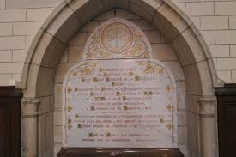“What emotion among those who had once known him and who today recognized him after a disappearance of forty years! Our Former Brothers burst into tears when they saw the loved face of the Father again. It seemed to them that, from his parted lips, a word filled with the love of God was about to spring forth... How many Pious Kisses fell on this forehead which seemed to reflect the Rays of Holiness! Many Mothers made their Grandchildren contemplate the features of this Great Childhood Friend; many young people bowed before the Venerated Remains of a Great Benefactor of youth: Priests have had their Breviary touched to the head of this Priest who recited his with so much fervor! Brothers approached their Father's Forehead, this Crucifix which he gave them as a Glorious Crowning of their Modest Costume; while the Nuns kissed their Rosaries, placed for a moment on the Face of the Great Servant of God.”*

Around three O'clock in the Afternoon, the Inner Coffin was welded and the lid of the Outer Coffin was then fixed, which was made of Norwegian Oak. At four O'clock, the Precious Remains of Father de la Mennais were lowered into the Vault Built for this purpose at the Bottom of the Chapel during the construction of the building and which had to be walled up by Formal Order of the Venerable Founder.

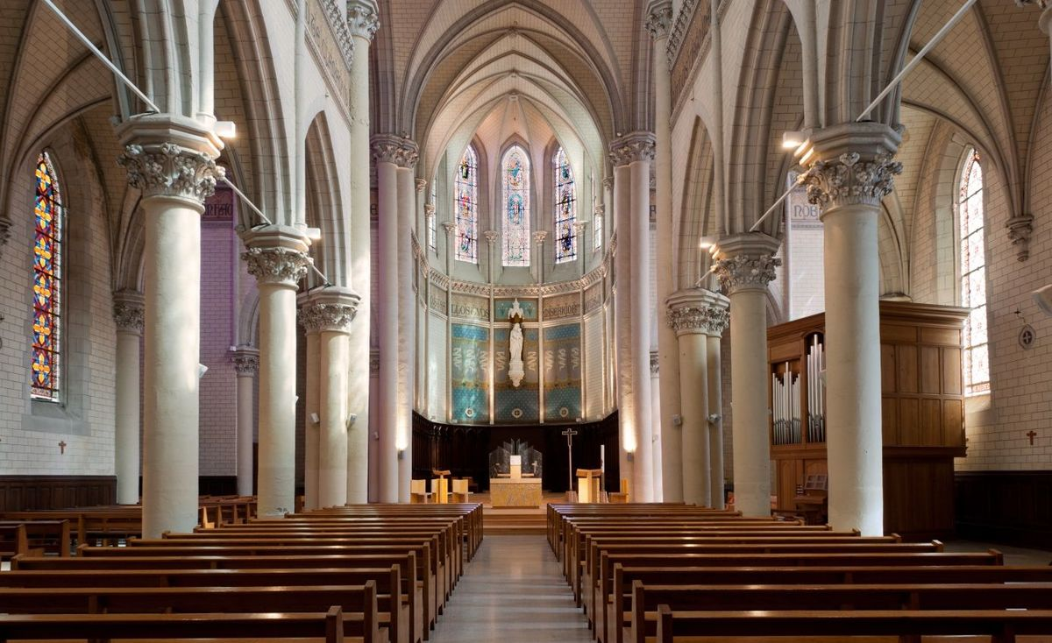From that moment on, the Tomb of the Father became the place of Incessant Prayer, of Invocations, of Intercession for so many necessities, of Supplications to resolve difficulties in the path of life, of words of Renewal and of Fervor. “Since the Venerated Remains of Our Founder were placed in the Chapel of the Mother House, many hearts have poured out in confident prayer, near the Tomb which contains them. Our Brothers began the Pious Parade; many Foreigners imitated them during the days following the Festival: this touching “Pilgrimage” never stopped. In the following days the Chapel had retained its Ornament and the Coffin had been left uncovered, so that they could touch some object on it. They could not see the Father, but their soul, more clairvoyant than their eyes, penetrated to the center of this Coffin where rests in the Peace of the Lord the humble servant of God: they felt that, from this blessed place, a particular grace, a delicious perfume escaped and made their prayer more fervent”.

Let us conclude by reporting the feelings of the Former Brothers, who had attended the Father's Funeral 40 years previously: “What a contrast, the elders told us, between the Ceremony of December 31st , 1860 and the Demonstration of August 6th , 1900! That day, everything was sad and dark and nature itself spread its cold mantle of ice. On this day, on the contrary, everything was about Life, about Joy and, from this field of rest, always so calm and sometimes so sad, everything today spoke of Hope, Glory and Immortality. ”

SOURCES: MENOLOGE pp.897-900/ CHRONICLE, September-October 1900, pp. 305-368 (entirely devoted to EXUMATION AND TRANSLATION)

1. **TRACES OF HOLINESS IN THE MENNAISIAN CONGREGATIONS: THE DAUGHTERS OF PROVIDENCE IN THE FIRST CANADIAN MISSIONS**

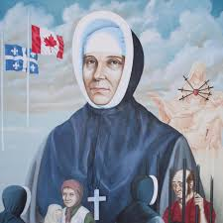The Daughters of Providence are the first Institute founded by Father de la Mennais. They were never very numerous, but he was always distinguished by his Fervor and even by his Heroism. We try to remember some Episodes of their Missions in Canada.

In the Wide-open Spaces of the State of Saskatchewan, several French-Speaking Immigrant Families, at the beginning of the 20th Century, had founded small villages: Prud'homme, Végréville, Léoville, Domrémy, Vonda, Saint-Front, Saint-Brieuc... In these Parishes the Daughters of Providence had been called to Direct Christian Schools and help Priests in the Work of Evangelization. Let's get to know the Small Convent of Léoville, the last of the Canadian Posts.

*“The village had barely existed for more than 8 years. Our Sisters were Established there in 1937. The Priest was completely devoted to the Sisters whom he himself called. The Old Presbytery served as a Convent. No Electricity, Central Heating Point; a Large Stove heated the Apartments on the Ground Floor: The Kitchen, the Refectory, the Utility Room where Vegetables, Canned Goods are stored, etc. On the First Floor, three Bedrooms, only one of which has a Door; the Entrance to the others are closed by a Curtain, not even an Attic. Each of the Rooms contained a Bed, a Rustic Table, a Chair, a Shelf for* B*ooks and Notebooks; no Wardrobe; the Single Trunk brought by the Sisters took its place. This was indeed Religious and Evangelical Poverty: Our Sisters were happy with it and desired nothing more.”*

The Lord is truly their only Wealth, because they had the happiness of keeping the Most Blessed Sacrament in the Small Apartment which served as their Chapel. For Furniture: An Altar with a Simple Cross on the Tabernacle, two Candlesticks for Mass, said by the Father every Morning, except on Sundays when it was celebrated in the Parish Church, also very poor. In the Chapel there was only one Bench for the Nuns; a Chair and a Prayer Table served as a Confessional. “But what fervor at this Mass, where every day around twenty Children attended and received Communion! We opened the Door leading to the Kitchen where the children, kneeling on the floor, pray with all their hearts. Our Sisters found makeshift Benches to sit them on. No Communion Table, so the Celebrant goes through the middle of the rows to give Jesus Host to the children. We cannot help but think of the Apostles and the First Christians.”

This was the “Convent” of the Sisters, very open to children. The School was a 5-minute walk from the Convent. In **S**ummer it was nothing, but in winter it was not pleasant. Our Sisters did not complain about it, although they keenly felt the bite of the cold! Families were very happy to be able to send their children to the Nuns' Schools. Currently 92 students attended the two Classes, but a third would have to be opened for next year. The President of the parents, father of eight children, was full of Joy at having obtained Nuns and expressed his great desire that God would deign to choose for him at least one Priest and one Nun. He had suffered a heavy Economic loss at work: “It was material ruin, but as long as we kept the Good God and Our Christian Faith, everything was good: there was another life in Heaven!” In truth, all parents showed great zeal for the Christian Education of their children. From Isolated Farms, numerous Cars came every Morning to bring the young students and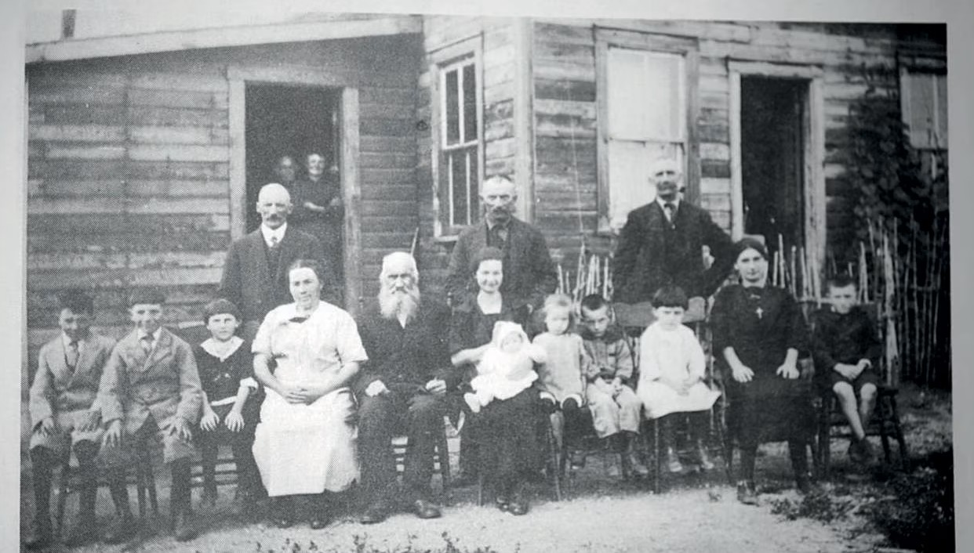 search every night.

**Saskatchewan landscape**

During the Holidays for the Daughters of Providence there was still work to be done. They took the opportunity to go two by two to villages far from Religious Centers to give, for eight or fifteen days, Intensive Catechism Instruction. They also dedicated themselves to work for another type: it was necessary to pick Fruits, Vegetables, and make various Preserves, in order to provide for the needs of the Community and its Residents during the Long Months of the Winter.

**A Family of Pioneers in Canada**

At the conclusion of a visit, the Superiors expressed their Enthusiasm for the visit to the New Mission. After the Songs, the Tributes, the Ornaments, the Photo Opportunity “we made a Triumphant Entry. Both Classes were filled to capacity, with all the students in their Sunday Best. We distributed Pictures and Sweets. The children appeared Simple and Good, and their Souls, still Brand New, seemed to us to vibrate with everything that was Beautiful, Great and Pure.” The Superior General, Mother Sainte-Rosalie, could conclude: “In Canada, as in France, the Congregation of the Daughters of Providence had remained very similar to itself, faithful to its Goal, completely devoted to the Christian Education of the youth, following the views of its Venerable Founder Jean-Marie de la Mennais.”

SOURCES: CHRONICLE OF FIC, N. 155, JANUARY 1940, pp. 189-194