

**MENNAISIAN NOVENA**

**SEPTEMBER 2024**

1. **POSTULATION NEWS**

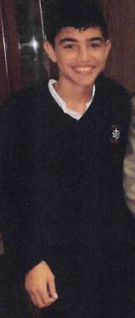We have received the response from the Doctor in charge of the Mater Dei Clinic in Buenos Aires, where Enzo Carollo received Treatment when he was Hospitalized from March 29th to May 3rd , 2006. He is currently the Director of Pediatric Intensive Therapy in the same Clinic. He answered the Most Controversial questions posed by the Medical Commission of the Dicastery for the Causes of Saints. He agreed to resume the Examination of the Case. In one passage he wrote: “As the Treating Physician, I could say that, given the Seriousness of the Case, Refractory Status Epilepticus, Coma, needed for Life Support, lack of initial response to the Treatments Implemented, Enzo’s improvement was not foreseeable.” Now we await the responses of the other Argentine Doctors and Nurses who were present at the Hospitalization. We particularly thank the Brothers of Argentina who are taking these steps. We also expect other responses shortly from Two Specialists in Infectious Diseases. Let us continue Our Trusting Prayer.

1. **PRAYER INTENTIONS**

We continue Our Prayer for Our Sick: ***Tommaso Leonetti*** (6 years old), he is out of danger and his health is improving; ***Greta*** (9 years old): she survived to the surprise of the Doctors; ***Liliana***: mother of 6 children; Alessandro (8 years old): Metastases everywhere, and for his non-believing parents; Our ***Brother Alain Josselin.***

The young ***Augustine*** of Uruguay went to Heaven, in an Atmosphere of Great Faith and Serene Hope. Br. Guillermo wrote to us: *“Yesterday, the moment of prayer and the evocation of his way of living the illness, will remain well fixed in the memory of the hearts of his friends. During a lesson, before the discovery of his illness, he had confided that he would have remained calm in the face of death and that he had no regrets: he had lived and was very happy. He touched Heaven before leaving. Looking at his friend who was crying for him, he took off his oxygen mask and said to him: “Calm down, Juan, calm down.” He did as Jesus did, who when dying did not concentrate on his pain, but cared for his Mother and his disciple who were suffering. Augustine also thought of his friend: “Calm down, Juan…” Yesterday in Uruguay was Children’s Day. Augustine taught us to have the faith of the little ones, to whom the Kingdom of Heaven belongs.*

1. **FAVORS RECEIVED, among the Daughters of Providence**

Prince Albert, Saskatchewan, Notre Dame de la Providence Institute.

*"Mrs. Emile Marcotte of Prince Albert had been suffering for several years; Operations seemed to result only in a Multiplication of Strangulated Hernias. Lately the poor patient found herself struggling with several of these complications at once. The suffering was intolerable, but the Doctor hesitated to operate on her, given the State of her Heart.*

*Two Nuns who had gone to see the sick woman sent her a Relic Image of Our Lady Father de la Mennais, recommending that she join in their prayers. “That same evening we began a Novena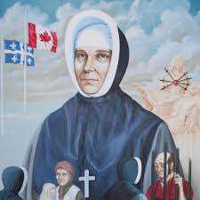 Prayers for this Intention. After two more days of suffering, the patient was able to be transported to the University Hospital of Saskatoon. The Operation was attempted against all odds. To the great surprise of the Doctors, the patient held on, as did her heart; and at this moment, Mrs. Marcotte is well on the way to recovery and is counting the days that separate her from her return home. Many thanks to Our Venerable Father de la Mennais »*. Sr Marie-Claire, FDLP

1. **DEVOTION TO FATHER DE LA MENNAIS :**

**THE SECOND EXHUMATION AND THE RECOGNITION OF 1926 in the DIOCESAN INQUIRY**

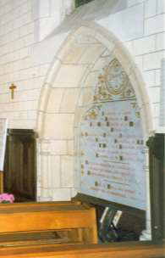On Wednesday, December 1st, 1926, the Ecclesiastical Tribunal responsible for the Trial of the Servant of God Jean-Marie de la Mennais, proceeded with the Exhumation and Canonical Recognition of his remains, deposited on August 6th , 1900, in the Chapel of the Mother House in Ploërmel. The Tribunal had the same President as in 1900: The Vicar General E. Dieulangard, Delegate of the Bishop of Vannes, Mgr Gouraud. The other Members of the Tribunal are four Judges; the Abbots A. Davalan, Notary; Boisrouvray, Promoter of the Faith; Camaret, Postulator and M. Bachelot, “Cursor”.

Unlike the Exhumation of 1900, the Operations were carried out with Great Discretion and in Privacy, starting at eight o'clock in the morning. Present were: Doctors Guillois and Lorieux, who had already operated in 1900; then the Workers: Masons, Carpenter, Plumber; the Members of the Tribunal and the Superiors of the Congregations founded by Jean-Marie de la Mennais, the Brothers of Christian Instruction and the Daughters of Providence.

At exactly 8 o'clock the asons began to work: they removed the Belgian Granite Tombstone. The Coffin was removed. The Wooden Casing, which was very damp, fell into pieces and the Lead Coffin appeared. It was taken to the Sacristy and placed on a table. It was opened. The Body appeared in its entirety and no Odor was emanating from it. The Mask [of the face] was still fairly well preserved and the main features of the Venerable One could be recognized. Only a few bones from the feet were somewhat detached: they were collected in a tin box, which was placed in the Coffin near the lower part of the right leg. Also found, to the right of the head, was a Metal Tube containing the Mminutes of 1900 and, to the left, the Box containing the Thumb of the Venerable Father Deshayes. They were put back in the same place. The Doctors were of the opinion that the body should not be moved; They made their Statement and it was decided to close the Lead Coffin which is then placed in a New Chestnut Casket.

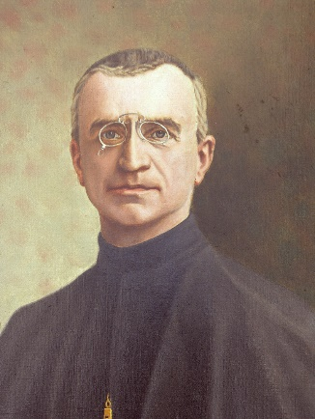It is wrapped in braid and the Bishop's seal was affixed in several places on Red Wax. Finally, the Coffin was replaced in the Vault which was again covered with the Tombstone and sealed. Two Boxes received the Sawdust that surrounded the Body, the sawn boards from the Old Coffin and the pieces of Linen that had been found there. They were protected by braid and sealed with the Bishop's seal.

This Ceremony, which took place in the Greatest Privacy, nevertheless lasted six full hours. At the end, the ***Superior General, Fr. Jean-Joseph Quirion***, thanked the Members of the Tribunal who, after having held a large number of long Sessions to hear the Witnesses in the Investigation, had still imposed this tiring day on themselves. He promised them that the children of the Venerable de la Mennais would have offered many prayers for them. The Superiors exhort all the Brothers and Daughters of Providence to fervent prayer for the Beatification of Father de la Mennais. “To tireless prayer must be added a Holy and Regular Life. The Fervor and Holiness of the children could contribute greatly to the Glorification of the Father.”

SOURCES : CHRONICLE (L'ECHO DES MISSIONS) n°. 77, JANUARY 1927, pp.149-151

1. **TRACES OF HOLINESS IN THE MENNAISEAN INSTITUTES:**

**BROTHER ANTONIN TULOU, FIRST MISSIONARY BROTHER TO DECEASE IN THE CONGREGATION**

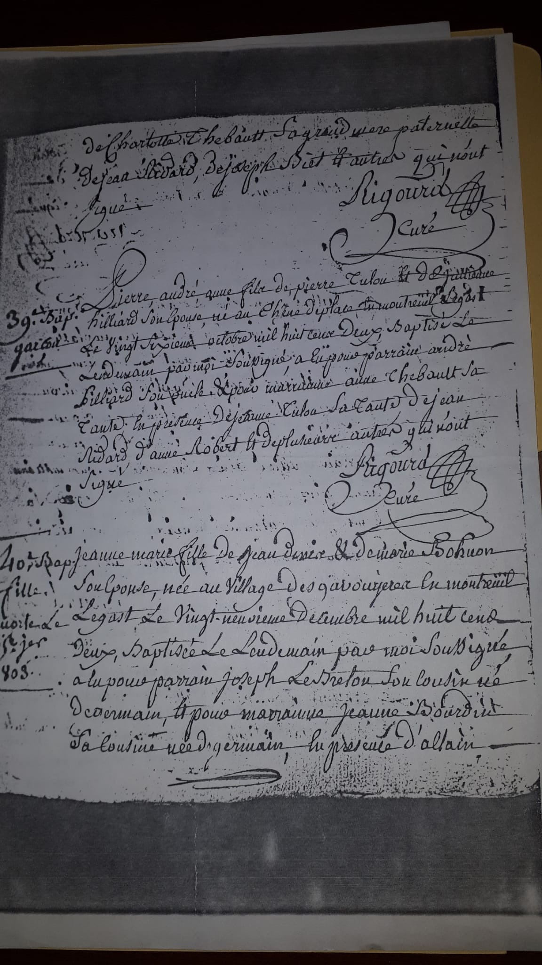Brother Antonin Tulou was part of the first wave of the “Founding” Brothers of the Institute. He was the first Director General of the Missionary Brothers in the Antilles and at the same time the First to be buried in the Colonies, in 1838, the very year the Missions began.

**CHILDHOOD AND ORIGINS**

**Baptism Certificate of Brother Antonin**

Pierre-André Tulou, the future Fr. Antonin, was born on October 26th , 1802, in Montreuil-le-Gast, a small Rural Town in Ille-et-Vilaine, which at the time had about 700 Inhabitants. In the Baptismal Certificate we could read: “Pierre André Anne, son of Pierre Tulou [alias Tuloup, but we follow the version of the Baptismal Certificate] and Julienne Hilliard, his wife, born at Chêne de Place, in Montreuil-le-Gast, on the twenty-sixth of October one thousand eight hundred and two, baptized the next day, by me the undersigned; his uncle was his Godfather and Anne Thébault, his aunt, was his Godmother. In the presence of Jeanne Tulou, his aunt, Jean Ridard, Anne Robert and several others who did not sign. Father Pierre René Rigourd, [priest from 1803 to 1839]” We know practically nothing about his childhood and his family, except that he lived in the Countryside, precisely at Chêne de Place (currently a field on the Gorzé Farm: Note from Father André Chesnais, Priest, letter dated June 5th , 1988)

We find Brother Antonin at the Novitiate. “He entered the Novitiate in 1822” (Friot EM18) At that time the only Central Novitiate was in St-Brieuc: The Recruits of the New Institute were converging in St-Brieuc, in the very House of Father de la Mennais. Father Deshayes, Founder of the Brothers in Auray, had left for the Vendée to accept his New Functions. Other Schools (Quintin, Dinan, Tréguier) provided Spiritual and Pedagogical Support. The effective Novitiate remained that of St-Brieuc. But it was full to bursting: there were 30 people: “we are on top of each other”. Pierre Tulou therefore returned to the Novitiate of St-Brieuc in 1822: he followed the Vocation of Brotherhood that he had perhaps discovered in the Schools recently founded in the Communes of Montauban (1819) and Tinténiac (1820), close to Montreuil-le-Gast. The Novitiate of Brother Antonin must have been quite eventful. We do not find the name of Brother Antonin, but in the list of Novices of 1823 he was named a Brother “Antoine”. It was Brother Isidore, a Brother from the First hour of the Novitiate of Auray, who directed the Novitiate. As soon as he was sent to direct the School of Tréguier, he was succeeded by Brother Ignace Le Roncé, who was in charge of the School of Montauban. The two Directors of Novices had to transmit the Initial Fervor of the First Brothers: they both came from the Heroic Novitiate of Auray, directed directly by Father Deshayes, who gave so many generous Brothers in the early days.

**TRAINING AND FIRST PLACEMENTS**

* During this period the Novitiate was looking for its definitive home and stable organization. The Founders first established it in Josselin in 1823, in a former property of the Sisters of Wisdom and in 1824 in Ploërmel, in the former Ursuline Convent. These were years of Travel and Research, made even more difficult by the absence of Father de la Mennais, who was in Paris, appointed Vicar General of the Great Chaplaincy. The more experienced Brothers replaced the Father, as best they could. We find Brother Antonin in Montcontour (FICR Archives File): was he there to supplement his Training? In 1823, Brother Ambroise was Director, one of the Pillars of the early days of the Institute, to whom Father de la Mennais was to entrust in 1824 the important School of Tréguier and a Small Novitiate which was annexed to it. Perhaps Brother Antonin had followed him and even collaborated with him. In any case, we find him as Director of the Novitiate in Ploërmel from 1826 to 1828: “he fulfilled this role for two years before taking over the direction of the School in Carquefou, in the Nantes Region, in October 1828”. This extremely important Appointment at the heart of the Nascent Institute at barely 24 years old is astonishing! A clear sign of the Superiors’ confidence, of his Spiritual Growth, of his observance of the Rule and of his ability to form Young Novices. We also have another particular fact: his younger brother, Jean Tulou, born in 1803, also became a Brother of La Mennais with the name of Brother Dosithée. He remained Director of the Ploërmel Boarding School for 30 years and rendered Great Service to the Congregation until his death in 1883. A fine vocation, to which the attraction of his older brother must not have been unrelated.

In 1828, Father de la Mennais sent Brother Antonin to found the School in Carquefou: “School founded and supported by the Priest, without the support of the Municipality”. We could note the following indication: “July 18th, 1833. The Municipal Council agreed to provide a Fixed Salary to the Teacher… to enable him to fight against the brother established in this Commune.” Obviously, the Religious Teacher, “the brother”, through the proper functioning of his Christian School had a great influence on the Population: it was necessary to find counter measures to his action! The First Brother and Founder of the School had been Our Brother Antonin.

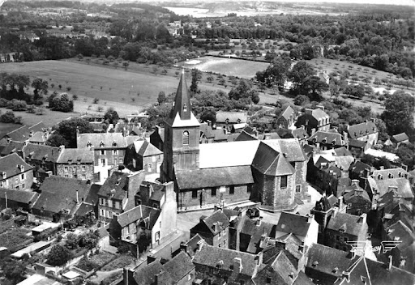

**Plouer on Rance**

Following in the footsteps of Our Brother, we found him in Plouer-sur-Rance, in the Northern part of Brittany. In this Town the Founder had established a School for Two Brothers, with Brother Louis de Gonzague as Director. In 1831 the Municipality abolished the presence of the Assistant Brother, under the pretext that there was another Teacher (mutual) in the Town. From that time on we found Brother Antonin as Director and Sole Master, until 1837. Naturally his Class was very large: in 1830-31 there were 90 Students, including 50 Poor People admitted free of charge; in 1832 there were 120 Students.

**ON A MISSION**

The call to the Missions surprised him in this position: he was 35 years old, in full maturity; he had shown a Solid Spiritual Formation; he had acquired good experience in the direction of a School, even a large one; he had frequented the “Solidly Pious” Brothers of heroic times. Perhaps he lacked the habit of having relationships of Authority with Assistants: this would prove to be the weak point of the First Missionary Community.

Aware of the importance of the success of the first sending to the Missions, Father de la Mennais carefully chose the Brothers who would be part of it:

-Br. Antonin, 35 years old, would be Director of the School in Guadeloupe

- Br. Léonide, 32 years old, entered the Novitiate at 28, had had good experience in Management and Administration at the Bréal School

- Br. Judicaël, 23 years old, the youngest, entered the Novitiate at 18, coming from the Management of the Caro School

- Br. Osmond-Marie, 30 years old, entered the Novitiate at 26, holder of a Small School

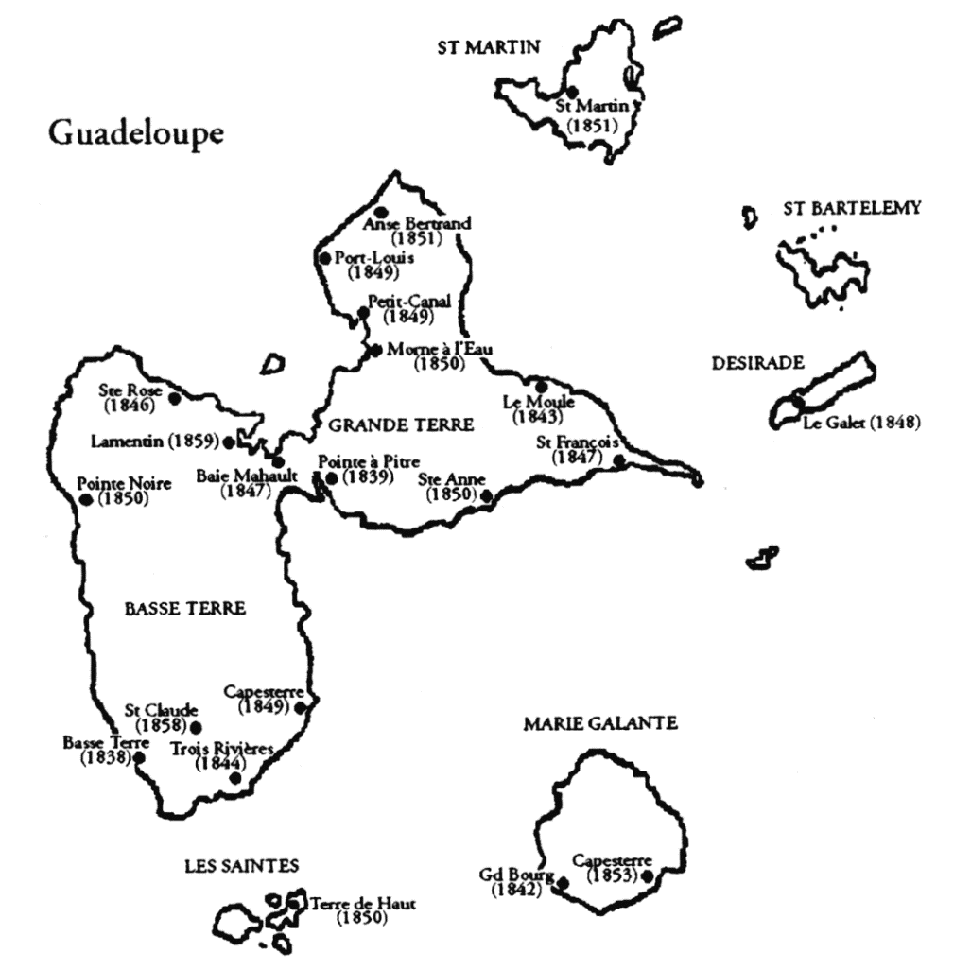- Br. Zosime, 30 years old, entered the Novitiate at 22, responsible for Domestic Work.

It was with great confidence, but also with the awareness of the fragility of these sons, that Father de la Mennais entrusted his sons to the Prefect of Guadeloupe, Bishop Lacombe: “Seeing these poor children moving away from me, I like to think that you would like to be their second father and give them advice often: they would need it in the new situation in which they would find themselves and where they would be exposed to so many dangers. I recommend that they contact you to find out to whom they should confess: their regularity and their piety depend almost entirely on it.”

The Missionaries, after the moving ceremony of sending on a Mission in the Chapel of Ploërmel, embarked at Brest. They had to wait a month for the wind to be favorable to departure. “Idleness, living conditions on Board, the too weak authority of Brother Antonin created a state of mind favorable to relaxation. The fear of the Founder, which he had indicated in Article 34, began to take shape: “The Brothers would be on guard against the spirit of independence and they would have no Will of their own”; I insist on this point because the Brothers destined for the Colonies are chosen from among those who have been Heads of Schools…” The Missionaries arrived at Basse-Terre on February 7th, 1838. They received a warm welcome from the Civil and Religious Authorities, but the premises - as almost always - are far from being prepared. Brother Antonin gave a precise description of the place. The Buildings, too narrow and in rather poor condition, form a disparate whole. “We only have lean-tos for Classes and for a home, filled with vermin of all kinds. Six Weeks after our arrival we slept on our Ship's beds. Our only furniture was six chairs and a table...” The Founder had warned his Missionaries: “It was likely that when they arrive the Brothers would find nothing prepared: they would avoid being too demanding.”

**THE SEAL OF THE TEST**

The First Community of the Mission experienced a real debacle. Between 1838 and 1841 it was completely replaced: one Brother died of yellow fever, another sent back to France, three left the Congregation. It paid the cost of the first experience, of the adaptation and the preparation of an unknown Mission full of dangers. The causes?

* The clash of Civilizations (A. Pesquer): destabilizing Climate, Customs far removed from those of a Christian Population, Indecency, Violence of Slavery…
* The lack of Guidance and Support from the Founder, despite the multiplication of his letters and the favorable aptitude of the Religious and Civil Authorities; but also, with a Clergy that was often Slave-Owning and not very fervent.
* The transgression of the Rule by some Brothers: Brother Léonide, appointed Bursar, wanted to manage the Community Fund above the Director, Brother Antonin, whom he found incapable in Administration; he often became Authoritarian and Violent; Brother Judicaël, the youngest, but demanding, independent and relaxed in the new Country; Brothers Osmond and Zosime, drawn into the wake of two others.
* The solitude of Brother Antonin. He saw himself relieved of all Authority by a Community that did not even consider itself as belonging to a Religious Institute and that did not consider him equal to his functions. He resisted, with the simplest Brothers, to try to fulfill the Mission that the Father had entrusted to him. But he felt a little abandoned by him: the Letters from the Founder are rare (only 2) and did not always respond to his requests.

**THE REACTION OF BR. ANTONIN**

In an attempt to meet the expectations of the Father who entrusted him with the task of opening the first Missions of the Institute, Br. Antonin would react with all his strength, with his humanly understandable limits, without calculating the cost he would have to pay.

Isn't the Founder there to advise him? He often consulted the Religious Authorities of the Island: The Apostolic Prefect Lacombe, the Sub-Prefect and the Priests of the Parishes of Basse-Terre Saint-François and Notre Dame du Carmel. In them he found advisers and support to face a situation completely unusual for him.

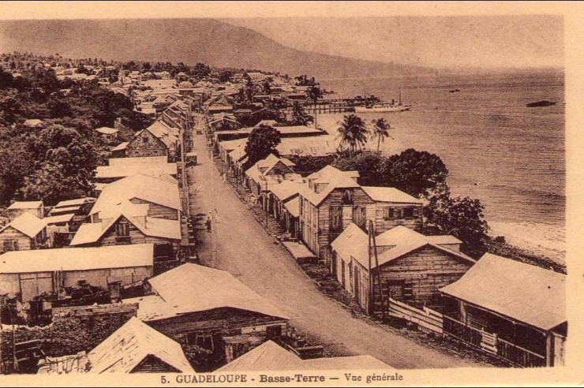

*For the Community, he avoided a direct power struggle; he tried to bring the Brothers back to reason, to encourage them to practice the Sacraments and to pray, by the example of his Spiritual Life. Indeed, they valued his Spiritual Dimension: “Our good Brother Antonin whose conduct* was *exemplary in what related to piety (Fr. Léonide) … Brother Antonin is a virtuous Brother, he is the example of all virtues (Br; Judicaël) … Brother Antonin was a very good Brother, but not in Housekeeping…” He often suffered in silence; he confided his complaints to the Father: “Send another Director. Perhaps he would succeed better. If you had given me the Junior Class, I would have been delighted. May I tell you with truth that I am the most unhappy of the Brothers. If I had stayed in Plouer, there would have been no one happier than me. What a change. Well! Since the good Lord Wills it, may His Holy Name be blessed…” He continued to set a good example, to be faithful to his charge, to trust in Providence.*

Finally, on April 4th, Brother Antonin succeeded in opening the School. The tables and benches arrived. With this objective, the Community tightened and, in the momentum, seemed to rediscover the Spirit of the Mission. “We started the Class; it was not going badly. We had 120 children. We could establish a Boarding School (perhaps he was thinking of his Brother Dosithée who ran the Boarding School in Ploërmel). We would not be short of students. Several have already offered.” For the moment, the School was attended only by freedmen of color. But Brother Antonin began to think of new steps in the Apostolate.

*“The establishment* ***wa****s going very well. The Brothers are well regarded. A Brother who has the Spirit of his state was precious here. There was good to be done in this Country; one must be detached from the goods of this World, be filled with the love of the good God, have in view only the salvation of souls, think that one has come to this Country only to win them for Jesus Christ. Many leave their Country to win souls, but being in the Country they change. For the good of the Colony it was necessary to seize the children and give them Christian Instruction. We have many children, however none of them have ever been to Confession. They are beginning to go now.”*

Despite the difficulties, the School was well organized: Brother Léonide taught the older Class, Brother Judicaël taught the second Class, BrotherS Osmond taught the younger ones, Brother Antonin taught all the Classes, especially the Beginners' Class, and Brother Zosime did the Manual Work. The Population of Basse-Terre appreciated the work of the Brothers: “The Supervisory Committee came away from the visit to the Brothers' School with a strong sense of satisfaction.” The Prefect: “They would have liked to see a little more unity among them, but they always showed themselves to be zealous in their 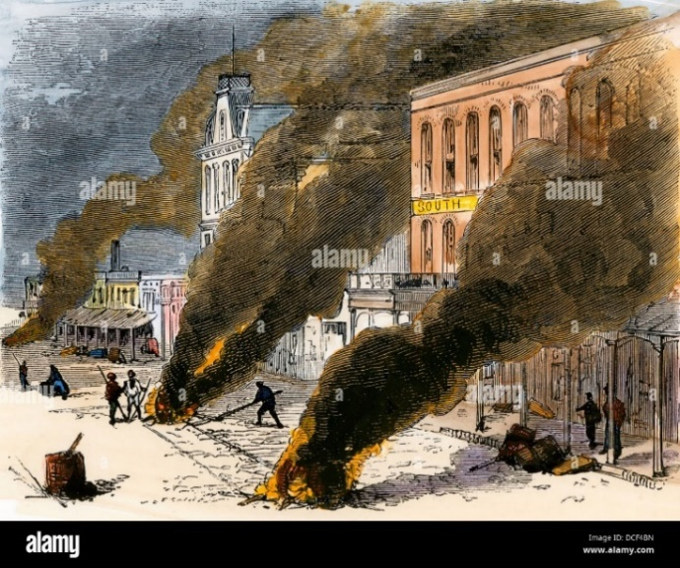duties.” This good reputation encouraged the opening of other Schools in the Colonies.

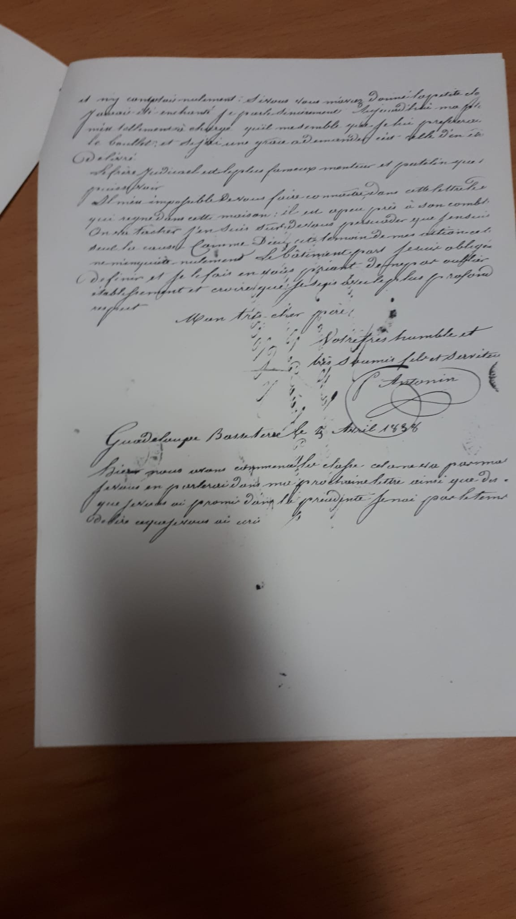However, the heaviest weight weighed on the shoulders of the Director. He felt almost abandoned by the Father, far from a Sure Guide, with Brothers who did not recognize his Religious Authority, in an unknown context, full of dangers and traps of all kinds, he resisted the terrible trials, solidly supported by his faith and his fidelity to the Rule. “Only one of our first five Missionaries, Brother Antonin, had always behaved as an exemplary Religious.” (Brother Cueff) Faced with the temptation to accuse the Father of having sent unprepared Brothers to the Missions and of having exposed him to so many dangers, he wrote to him: “I think that you have done your best and I do not blame you. Good Lord has allowed it to be so. May His Holy Name be Blessed!” After receiving a letter from the Father: “I did not condemn you, because in examining things, you could hardly have acted otherwise.” In a moment of great discouragement: “I would confine myself to telling you that I have never been so bad in my life. My God, I don’t know what to do. I would like to be in France in the most unknown desert. I have not yet lost courage, I console myself in Jesus Christ crucified.”

**UNTIL THE END**

Brother Judicaël was repatriated on July 20th. In France he recovered: he was entrusted with School Management and he died in the Institute. The climate of the Antilles had contributed to his “unworthy conduct.”

**Yellow Fever in Guadeloupe**

But another ordeal immediately broke out: since Mid-July a Terrible Yellow Fever Epidemic had been ravaging Guadeloupe. It would rage for several Months and would multiply the victims especially among the Europeans: “there were 600 Soldiers in Guadeloupe, 500 died and a crowd of Creoles or Creolized people; Yellow Fever had never been seen more active. Everyone was in the Countryside, the City was deserted.” (November, 1838, Fr. Osmond) Brothers Léonide, Osmond and Zosime fell ill. Classes were suspended. The Administration rented a Country House for the Community about 5 km from the School, on the heights “to recover the sick and protect us from the Disease that is running around”. The Brothers occupied it from the end of August. Brother Antonin was doing well: “I enjoy, thank God, perfect health. This was not the case for the other Brothers. I saw myself standing alone. Brother Osmond was well, Brother Zosime was convalescent, Brother Léonide got up from time to time, but he was far from being well. The Brothers remained on these heights with the servants.” And him? There was a moment when fear took hold of him: “Seeing almost all the Europeans dying, I was afraid for a while and I expected illness or death. I am beginning to reassure myself and I thought that I would be preserved from the Epidemic, as well as the other Brothers.” He was well aware of the danger and the Seriousness of the Disease (“in three Weeks we lost 4 Priests…”), but he saw himself in good health (“the Doctor told me that I was tough”), he noted the recovery of the other Brothers, he trusted the voices that announced the end of the Epidemic: they said that the Fever was decreasing, that there were no other people infected. These motivations explained the Director's "unwise" conduct. "I went up to the Country House in the evening and come down in the morning, that was to say I spent the night there and the day at Basse-Terre". He was not unconscious. He knew that Fever was a terrible threat. "Of 100 Passengers who came here, 50 of us are left". But he was determined to go all the way: "let it not frighten the Brothers who are to come here". He made plans for the School: "We were given a Month's leave. We would distribute prizes in January..."

**Letter from Brother Antonin**

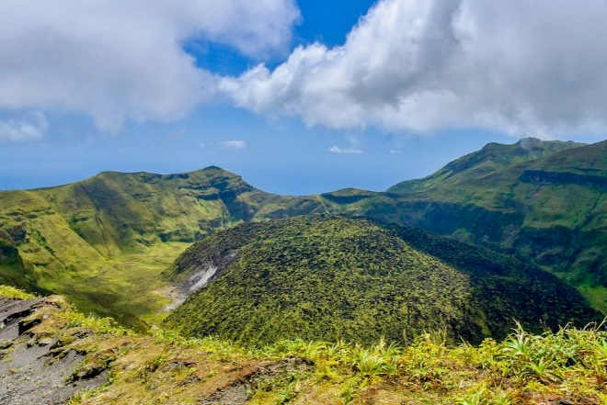*“Brother Antonin would have escaped if he had known how to take advantage of the kindness of our Benefactor [to stay at the Country House]. But he was content to come there quite late and leave early in the morning to go to the* Ci*ty where he died in the midst of the most cruel anguish.”*(Br. Leonide)

Little prudence or boundless Apostolic Zeal? Yellow Fever was not to stop his Missionary Duty. He felt in good health, for a Month he covered the 5 km in the morning and evening, he said his Prayers of the Rule, he ensured a presence in the School for its maintenance, to welcome people, perhaps the children. He saw this presence as his duty. He entrusted his life to the Providence of God. He took every precaution: he asked for the Brothers the free assistance of a Doctor, but he knew that his existence was in the hands of the Father, like Jesus he abandoned himself to His Will.

Let us take as a conclusion the “prophetic” words of Brother Léonide, one of the Brothers who had made him suffer the most. “It is true to say that at all times the work of God has had obstacles to overcome and difficulties to conquer. The establishment of Guadeloupe was perhaps one of these, because it had barely been in existence for a few Months and had already passed through several trials. But it seemed that Providence wanted to cap it all by taking Brother Antonin from us. This poor Brother having been struck down by Yellow Fever died on the 4th of this Month (October), after 11 days of illness, in the midst of the cruellest anguish.” Brother Antonin was the first grain of wheat to fall on Mission Land: he gave his life in the midst of trials of all kinds, he opened the First School to Evangelize young people in the Colonies, he led a Community with Wisdom and Patience, he sacrificed his life entirely for the Mission. He was the First Missionary of the Institute: the Patron of the Mennaisian Missions.

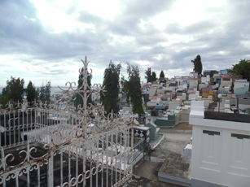

**Basse-Terre Cemetery where Brother Antonin was buried**

The Basse-Terre Cemetery contains the Mortal Remains of 25 Brothers of the 94 who died in Guadeloupe. The first to be buried there was Brother Antonin Tulou, Director of Our First Missionary Establishment, who died on October 4th, 1838, Eight Months after his arrival on the Island. The small monument, restored around 1975, was by Mr. Hubert Ancelin, a former student of the Brothers, who died in 1940. (Br. P. Cueff)

SOURCES: P. Cueff, EM 1, ORIGIN OF A MISSIONARY EPOPE/P. Cueff, EM 11, THE ORIGINS OF THE FICP/ Friot EM18, THE EXPANSION OF THE FIC/ Letters from the Brothers of Guadeloupe Box 168 AFICR/File F. Antonin Tuloup AFICR/A. Pesquer EM 49