MENNAISIAN NOVENA
JUNE 2024
- POSTULATION NEWS
The Postulation was called to the Chapter to take Stock of the Current Situation of the Cause of Beatification. In Summary:
- Specialist Doctors are still studying Enzo Carollo's Recovery. With the Brothers of Argentina, we contacted Doctors present during little Enzo's Hospitalization. We presented them with a Quesstionnaire to Record their Memories.
- The Brother Postulator, at the request of the Superiors, presented a Report to the General Chapter on the current situation of the Cause of Beatification and the work of Postulation. Here are the Main Points Covered:
- ANIMATION OF DEVOTION TO THE FATHER: the impression is that it is increased, favored by the Institution of Local Animators; the Monthly Novena is well Distributed, Facilitated by the Internet, with New Sections and the Presentation of the Biography of “Saint” Brothers.
- UPDATE ON THE HEALINGS PRESENTED: for Josette Poulain there was a “Suspensive” Judgment; we took up the case of Enzo C.; the Postulator exhorts to resort to the Intercession of the Father, to use Relic Images, to Organize Novenas, Pilgrimages, etc.

- POSSIBLE INTRODUCTION OF CAUSES FOR BEATIFICATION OF SOME BROTHERS
It had already been requested in the Chapters of 1984 and 1990. The Postulator explains the Canonical Procedure to follow and indicates the Names of Brothers who could be presented: Brother Hyacinthe Fichou, Evangelist in the Antilles; Brother Zoël Hamon, one of the first Brothers of Heroic Times: Brother François Cardinal, “Martyr” Missionary in Rwanda. “The memory of our “Saints” is a Living and Incarnate Memory of the Charism of the Institute, a powerful sign of unity of Our Religious Family, a concrete Invitation to our Sanctification, Encouragement to Apostolic Creativity in the Holy Spirit, Direct Vocational Attraction and Passionate, Special Protection for us and Our Mission”.

- INTENTIONS OF THE NOVENA
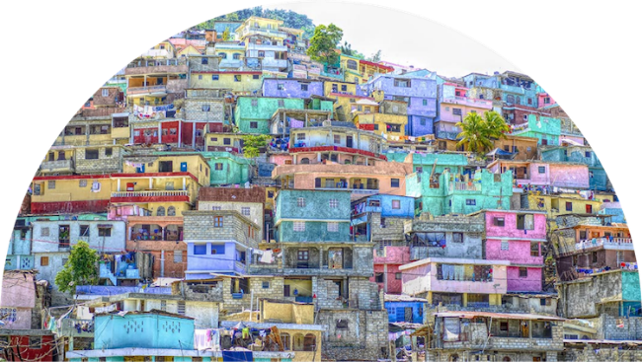
We will continue to pray for Brother Alain Josselin. He received Treatment in a Specialized Clinic, with slow improvement. From time to time he can spend a few moments in the Community of Brothers in Rennes.
Let us also ask for the Protection of the Father over the Population of Haiti: that they may very soon find Social Reconciliation and Justice, in this Country where the IC Brothers have been present for 160 years and where many Brothers have offered their lives.
We pray for the Local Intentions indicated by the Brother Animators. Let us not hesitate to resort to the Intercession of Father de la Mennais to ask for Healings, even in the Most delicated and difficult Cases: Our Father, in one way or another, will be close to us and he will help us. give Protection.

- FAVORS RECEIVED
In Spain, at the “Casa de Preservacion”: Healing of a Sick Child.
In Bilbao the Authorities had established a Home for Young Minors with Serious Family Difficulties - Le Refugio - and had entrusted the Management of this work of Great Social Value to the Brothers.
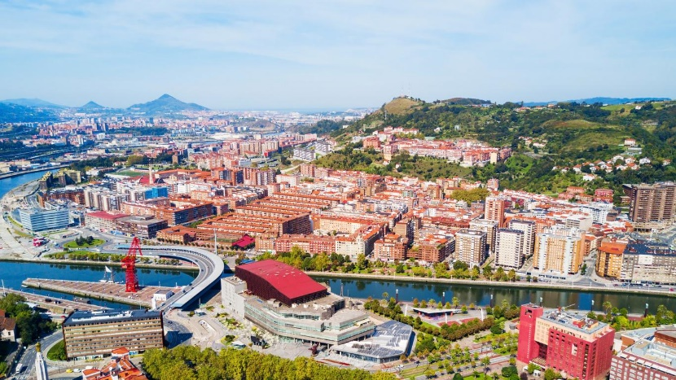
In 1922 the Authorities had detached the Section for the Youngest (6-10 years) from the Refugio, to preserve them (Casa de preservacion) from the Possible Negative Influence caused by Promiscuity with older young people. This Section of the Youngest had been established in Nanclares and entrusted to the Brothers, who became Fathers to these Little Ones. In this House, in very close contact with the young people in Formation, Devotion to the Father was Very Alive. We usually resorted to the Protection of Father de la Mennais. We transcribe this story following the Annals of the House.
Bilbao, Today
” That year [1926?] the Good Lord wanted to test the children of the “Casa de Preservacion” with Illness. In the last days of January, three of Our Students, José Cueto, Pablo Rubin and Angel Pereda had to go to bed with Typhoid Fever. The Doctor, Dr. Mariano Rodriguez, who visited our little patients with Special Interest, declared on the evening of February 2nd that the almost imperceptible pulse of José Cueto, whose condition had worsened considerably, was causing him serious concerns. To revive the heart, he made the little patient take a “Strophantus” Pill. Having asked him at what time it would be appropriate to give him another, he replied: “Tomorrow morning, at eight o'clock, if the child is not dead.”
On this, not very reassuring statement from the Doctor, we began a Novena to Our Venerable Founding Father to ask him for the healing of Our Three-Sick people, provided that this was in accordance with the Good Pleasure of God. Prayers for the same purpose were recited in the Novitiate and requested in several of Our Houses. A Mass and a Novena were promised in Thanksgiving. A Relic Image was placed at the bedside of Each Patient.
José Cueto spent the Entire Night Delirious. At dawn he stopped speaking. Was this the end? No. The fatal hour predicted by the Doctor did not arrive. In the morning, at 8 o'clock, not only was the child alive, but his General Condition, although very serious, presented a better appearance, which excited us to redouble the fervor in our prayers to the Venerable Father. Healing was far away: the little sick man lay unconscious and unable to utter the slightest word. But he lived. Our students, realizing the anguish that gripped our hearts, did not give rise to any reprimand; on the contrary, uniting sacrifice with prayer, they wanted to make themselves worthy of the favor they requested. At the end of the first Novena, José Cueto was out of danger, which made the Doctor say: “We should not seek to penetrate the secret designs of God, but I would like to know what to attribute this Radical Change to. If this had happened to my son, I would not hesitate to say that God restored his life.
Pablo Rubin, despite the strong and painful emotions caused by the presence of his companions, recovered fairly quickly. It was not the same for Angel Pereda. God had decided to call him to Himself. This poor child, in poor health and having already suffered from Several Serious Illnesses before his arrival in Nanclares, suffered a Serious Hemorrhage on the night of February 6th. Two days later, seeing that the supreme moment was approaching, he himself took the Image of the Venerable Father and kissed it several times with Touching Veneration; then, having received the Last Sacraments with sincere and Profound Piety, he returned his beloved to God on February 8th at one o'clock in the Morning. His mother was able to see him before the Funeral Ceremony. His mortal remains rest in the Small Cemetery of the Community and his soul - we hope - enjoys the Glory of Heaven, because this child always had exemplary behavior during his stay at the Casa de Preservacion.
José Cueto's Convalescence was long. The child spent almost the entire Month of February without being able to utter a word; but the healing, so ardently requested, nevertheless grew stronger every day. It has been complete for a long time. Today the child is doing wonderfully and for him, as for the others who witnessed his illness, his healing is due to the Intercession of the Founding Father. So, it is with all our heart that we fulfilled Our Promise. The Novena was recited with fervor and the Mass Solemnly Sung on April 26th. Thanks, be given to the Father. Thank you also to everyone who cared about Our Patients!
Doctor's Statement: “Given the nature of the illness suffered by the children named above, and although it is not true to say that this illness is fatally fatal, the case was nonetheless very significant for young José Cueto. great probabilities of ending in death, which I do not doubt for a moment in recognizing that, in the healing that occurred, seems to have contributed a supernatural aid or an unsuspected natural aid no less worthy of admiration for that and which does not absolutely exclude the Favor of Intercession.”
Signed : Mariano Rodriguez”
SOURCE : COLLECTION OF BR JEAN-CHARLES BERTRAND
- TRACES OF HOLINESS :
BROTHER LUCIEN-CLAUDE SEVENO (1929-1962): 33 YEARS OF JOYFUL OFFERING

In Health and in Illness, in Strength and in Decline, in Well-Being and in Pain, Brother Lucien gave Everything with Joy.
FIRST YEARS
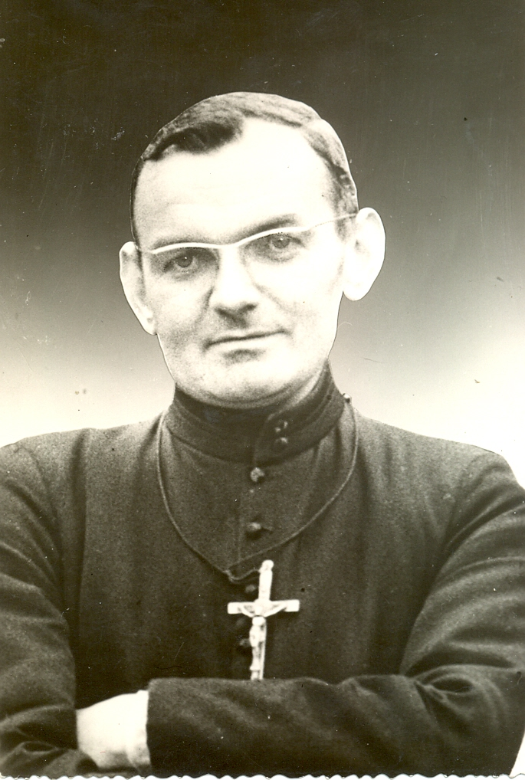
BROTHER LUCIEN-CLAUDE SEVENO
On January 1st , 1929, the Séveno family received as a gift from Heaven this fifth child, who at Baptism received the name Jean. Among his eleven brothers and sisters, he benefited from a Solid, Simple and Happy Christian Education. In the village of Téno (Plumergat, Morbihan), the family operated a Small Farm. Little Jean and his brothers could have great adventures in a Rugged, Wooded Moor and on the rather Wild Shore. In 1933, the owner taking back his land and the family becoming larger, the Séveno family looked for a New Farm and found it in Combourg. This Small Town was marked by the Mennaisian presence: here the Founder came to visit his sister Marie and he founded one of the first Schools of his Brothers. Jean and his brothers attend this School. He had the chance to meet Brother Cléomène Loret. “Every morning, he came to work diligently, happy to explore this field of Science. In the evening, returning with his brothers, after leaving the Main Road, we saw him opening his Lesson Books.
TRAINING IN THE WAR YEARS
Living alongside the Brothers, he felt called to the service of the Lord like his Masters. In September 1941, led by his Master F. Cléomène, he entered the Juniorate of Janzé: he was 12 years old, he began the sixth School year with enthusiasm. He continued his studies with discretion and great application, giving full satisfaction. Everything seemed to be going normally, but we were in the middle of the War years. Training continued at the Postulancy in Roscoat Castle, in the Middle of the Woods and away from Towns. Its teachers are Young and Dynamic. The Thrifty Brother managed to work Miracles to provide Supplies for the House. After a year of Postulancy, you must go to Ploërmel for the Novitiate. The year is 1944 and it is the year of the landings. The young Novices join Ploërmel aboard a Military Truck. When they arrive at the Motherhouse, they experienced great disappointment. After 4 years of German occupation and a recent Bombing: Broken Windows, Blackened Walls, Damaged and Ugly Lawns. Fortunately, Brother Théogene Mahé, Master of Novices, quickly raised Morale, with his Warm Welcome and his Words of Encouragement.
Jean Séveno became Brother Lucien-Claude. He gave himself entirely to his Formation: he took care of his life of union with God, he studied the Rules in depth, he cultivates friendship with his colleagues, seasoning it with his Acute and Innocent Humor. The two years of Scholasticate followed: he applied himself greatly to his studies, but he noted that “Spiritual Progress did not go hand in hand with Secular Culture”.
HE STARTS HIS LIFE AS A BROTHER
The First Obedience sent him to Bain de Bretagne, as Supervisor at the Boarding School and Drawing Teacher, then Teacher in Eighth Grade. In his free time, he pursued his Personal Studies, “while giving himself entirely to his Task as Supervisor, which he interprets as the main agent of Education”. From this First Apostolate, he left his notes: “Lord, preserve for me the esteem of my Beautiful Vocation, now that I am in direct contact with souls I understand better the Nobility of my Mission.” He wants to improve his approach with his students: “We must repress movements of impatience and treat children gently and firmly. I want to be immensely good and strive to usually have a kind smile”.
In 1950 he took the Decisive and Irrevocable step: offering his life to the end in Perpetual Profession. His New Mission Field is Notre Dame in Rennes. He enrolled at University to study for a Degree in English, which he completed in two years. At the same time, he was in charge of a Class, to which he gave himself generously. He noted in his Notebook: “Lord, teach me to simply fulfill my State Duty - a thousand daily nothings -/ to be careful to be very Concrete in Teaching/ not to bully my students or make fun of them; above all, never talk about it except in Good Terms/be Luminous and Clear.” He seriously prepared his Class. He read a lot, pen in hand: his notes record analyzed Books and Films to present to young people. In 1952 he was able to go to England to improve his English. He was distinguished by his desire for ideals and to give of himself; he continued to take care of his students by maintaining an Abundant Correspondence with them. For a few Summers he organized Courses for the Brothers in Finistère: behind a serious appearance, he was very welcoming and he had a weakness for the older ones who had more difficulty assimilating.

A DEEP SPIRITUALITY AND OVERFLOWING APOSTOLIC ACTIVITY
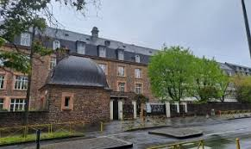
The Assumption in Rennes, Today
In 1956 F. Lucien was placed at the Notre-Dame de l'Assomption Institution, recently accepted by the District of Ille-et-Vilaine, to open a Secondary School. He taught French and English in Second Grade. Providentially at the beginning of his more important Apostolate, the Superiors gave him the favor of experiencing the Great Spiritual Retreat.
SPIRITUALITY
Let us always read in his Notebook: “I made a Discovery during this Great Retreat: it is that my life must be attached to something solid... The Lord revealed Himself to me as someone Alive, as a Person, not as a Vague Notion. I had the Grace to meet Him, a bit like the Disciples of Emmaus... Thinking about this Intimacy with the Lord especially when my loved one is in a Tunnel. So, don't forget that it is still there, because left to me alone. I can do absolutely nothing... Soon plunged back into action, I must consider it as an extension of my Union with the Lord... it is part of my relationship with the Lord. Morning prayer should not be limited to half an hour, it is rather an inner disposition for the whole day... May my lover naturally orient Himself towards you, like a Magnetic Needle..."
EDUCATION
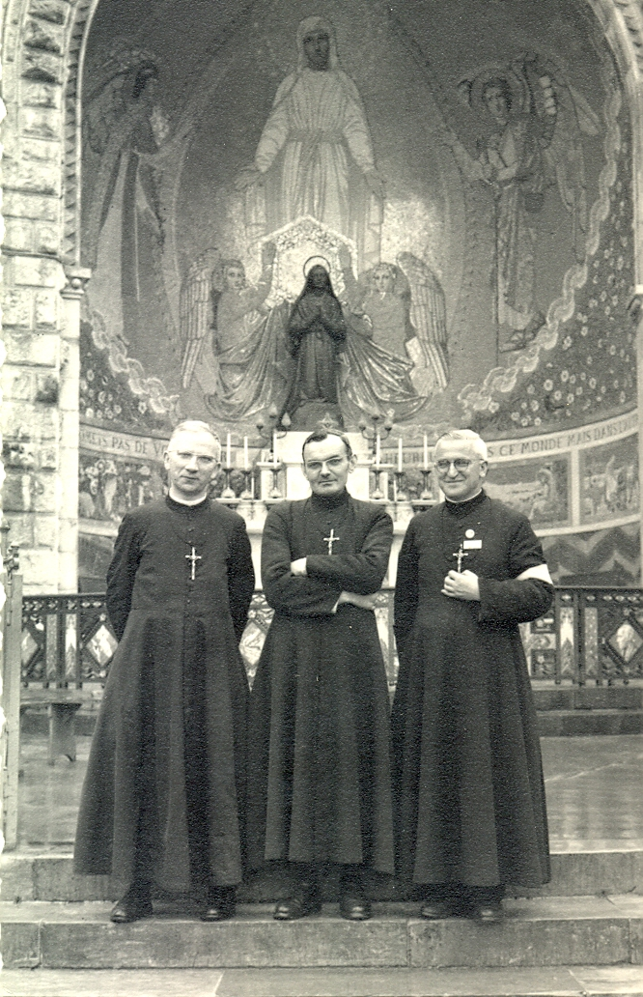
With these attitudes, Bro Lucien launched into an overflowing action centered on the Apostolate. His strong personality marked all his Activities and, in particular, his Teaching. He had the Art of interesting his students, through his knowledge and his enthusiasm. He is a highly esteemed Educator and much loved by his students. Let's read some of their Testimonies. “Bro Lucien knew how to adapt his Religious Views without distortion to the youth around him, thanks to a Marvelous Liveliness of Mind and a Great youth of Heart. He knew how to share his knowledge with clarity, all with a Humorous Tone that was never out of place that was maintained in his Lessons, which were also given under the Trees as well as in the Classroom, as the Authority of the Teacher was so established... He used the Latest Techniques for his Lessons, playing us School English Records or even recording us on a Tape Recorder to correct Our Accent... The Best Memories I would keep of the F. Lucien would be those of this Second Class where the limited number allowed a real family life. I remember an Excursion at the end of the year in the Forest of Paimpont, where Brother Lucien played father among the interns during the Picnic... It was he who guided my first steps in the dissertation and which also formed my judgment… What made him so sympathetic to me was that in him I met the man of God who perfectly understood our problems. He saw far and right in the area of ​​Christian Formation... When last year we only had one hour of English with him, he did not abandon us. I loved discussing my future, my future studies and my plans for the future in a friendly manner with him... Perhaps, in addition to his vast knowledge, he managed to instill in me his dedication to young people. I will be very happy to take his place among the young people… he was not a Teacher who harped on his knowledge from one year to the next; he added his ever-growing and varied Personal Culture to it.”
In Lourdes
SPORT AND CULTURE
A Sector particularly cultivated by Brother Lucien was Sport. Let us always listen to his young witnesses: “His astonishing vitality disposed him to take care of Sporting Activities, which he did with Great Taste and Enthusiasm. He rightly believed that Physical Development must be added to Spiritual and Intellectual Nourishment. Also, with what heart he gave himself to it and, with his Sense of Organization, he achieved wonders. He trained his Football, Handball, Basketball and Volleyball Teams Methodically, imposing Team Play, so much so that when entering the Competition, the Colors of the Lycée de l'Assomption shine in the Stadiums and in the Sport Halls. The Coach closely followed his Athletes. He would like to be present everywhere to accompany Juniors, Cadets and Youngest Children on Thursday afternoons during Competitions: he took his Bike and went to encourage his people and Force Victory. In failures he consoled himself and boosted his Morale: “After all, the young people played and that is the main thing.” It extended its Sporting Scope to the Diocese and even beyond. He was one of the Organizers of the La Mennais Cup for the Centenary of 1960. His collaboration with the Diocesan Management earned him the Dedication Medal to the Sporting Cause, awarded by the Ministry of Youth.
In addition to Sports, he managed to add more Intellectual Leisure Activities for his students in other areas of Culture: Conferences, Watching Valuable Films, Film Club Discussions, Hearing Concerts, Theater Performances, Instructive Excursions, etc.
ILLNESS AND SPIRITUAL ASCENSION
Why must such momentum break? One day in June 1960 a visit to the Dentist revealed a Serious Illness. The Doctor feared Tongue Cancer. Analysis of a sample confirmed the Diagnosis. A Treatment with Radium Needles initially seemed to get the better of the problem, so much so that at the start of the School Year in September he was able to return to Class with its many Activities. Unfortunately, the Disease reappeared after Easter 1961 and, despite all the Care and Rest, Brother Lucien had to abandon all Educational Activities.
The Brother with multiple occupations, always on the run, finds himself from one day to the next without any prospect of action. He has, thank God, a Providential Basis of Faith and Prayer, but in any case, he must make a Spiritual Turnaround which required a Dramatic Effort. After two years of this journey which led him to the pacification of his heart, he was able to confess to Sister Yves-Marie, his sick nurse: “Fortunately we do not know the future. If I had known two years ago what awaited me, I would have revolted.” But at the same time, we can note the enormous progress in “Sanctification” that he made by reading the note he wrote a few hours before dying: “Grace is something formidable, I felt it in a tangible way for two years. Everything that God sends us is accompanied by the necessary Graces. And Prayer, what power!”
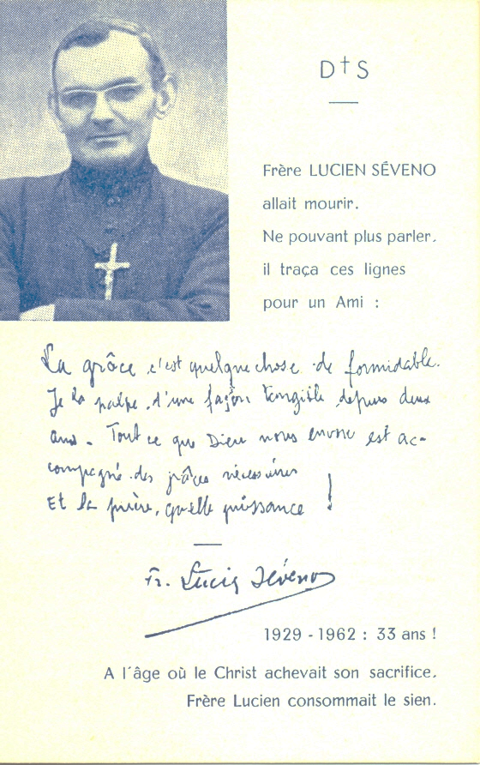On October 20th, 1961 he entered the Clinic. He puts Sister Yves-Marie at ease by confiding in her that his case has no remedy and that the main thing is to prepare him to ascend to Heaven. However, he submitted obediently to all Treatments and joined in all the Novenas for his Healing. He knew that the goal is not to obtain the Miracle, but to help him accomplish God's Will. And to the Sister who complains that God does not listen to Prayers and that there is no point in continuing the Novenas, he responds sharply: “But you are Blaspheming!” And when he experienced almost unbearable pain and his Nurse urged him to Pray to God to come and get him, he replied: “No, it is not ours to order. He is the Master. He knows better than us what he Has to do.”
He finds the strength to relieve other sick people. Next to him a young man, Jean-Claude, suffering from Cancer in his leg, is unaware of the Seriousness of his Illness. “Oh, we must inform him of his condition; he has a unique opportunity to make a Beautiful Sacrifice.” When he has attacks of Acute Pain, he sits in his chair, head in his hands, silent or curls up on his bed. He draws his strength from Prayer, especially from the Rosary, which he asks Visitors to recite to unite with him. Every Evening, with his Nurse, he renews his offering: “My God, I believe in your Infinite Goodness. I put myself in Your hands. Do with me what You please, leaving me only the consolation of obeying You.” His Notebook records his Spiritual Journey: “Illness and Suffering bring us closer to God. Before the Illness, I was a thousand kilometers from Him; now I am so close!... Without this ordeal I would have only been a Scoundrel... We must be indulgent for those who fall... A kind, helpful person is more pleasing to God and does better to those around him than 'an Austere and Mortified Person...'
…There are many friends who come to be edified by his contact and his influence is strong on all those who approach him. But the Disease progresses: soon speech loses its clarity and it is additional suffering to no longer be understood. He was given a Slate on which he wrote Requests and Answers, always asking to end a Visit with the Recitation of the Rosary. As a great gift from the Virgin, whom he loves filially, he participates in the Lourdes Pilgrimage organized by Father de Montfort. He is on the Sick Train with his young friend Jean-Claude, over whom he would watch during his stay in Massabielle. He would be followed by the Volunteers and also by the Brothers of the Communities of Lourdes: we kept a moving photo which represented him in the Middle of two Brothers in the Basilica of the Rosary. These were days of Joy and Grace for Brother Lucien. “You must have seen him pray at the Grotto and at the Swimming Pools.” Every Afternoon he bathed in the “Miraculous” water. On the last day he came out broken with emotion and his eyes filled with tears of confidence and gratitude. On the day of departure, a Serious Hemorrhage was stopped by water from the rock: this was not Healing, but a small delay to complete the work of grace. On the Train that took him back to Rennes he announced with confidence: “I will go see the Blessed Virgin within Three Months.”
A few days later, Brother Lucien would make a Second Pilgrimage. A Simple Pilgrimage, but a Family One: he went to Ploërmel, to the Tomb of his Founding Father Jean-Marie de la Mennais. He made a Visit there to give thanks for all the favors received during his Illness. He also reached the Small Cemetery where so many Brothers Rested, whom he wiould soon find in Heaven. Returning to his Clinic, he prepared for the Big Trip. On June 12th he invited all the Staff to assist him during the Reception of the Sacraments of the Sick. He followed the Ceremony in his Little Missal with Great Piety. At the beginning of August, the crises multiplied: during a crisis which was believed to be the last, he never stopped Praying and Kissing the Small Statuette brought back from Lourdes and asked for the Rosary to be recited. A little calm return slowly. August 3rd with the Sister recited the Prayers of the Dying. “In the Evening, he bid farewell to his Family, inviting them to rest. After the usual Injection he fell asleep until two in the Morning. Waking up is painful and the patient only finds a little calm when the Sister and the two Brothers who watched over him saying the Hail Marys. It was at the end of the Fourth Decade of a last Rosary that, gently, Brother Lucien returned his Soul to God.”
The expected News was quickly communicated to everyone: it was Sadness, but also Admiration and Gratitude for this Brother who was generous in his Apostolic Action and moving in his Faith during his Illness. The Mortal Remains were on display in an Ardent Chapel at the Institution of the Assumption in Rennes: there was an Uninterrupted Parade of Visitors. A Collected and Moving Crowd filled the Room in the Prayer Vigil presided over by Father Mérel, Vicar of the Parish.” The next day the Procession which took Brother Lucien to the Church had nothing Funereal about it. The Crowd chanted in French and although tears flowed from many eyes, they were full of Hope. Many Confreres sang the Office of the Deceased, the Parish Priest wanted to say farewell to the Parishioners in front of the Huge Assembly. At the end of the Celebration, the Choir Intoned the Magnificat according to the desire expressed by Brother Lucien. Before leaving for Ploërmel, the Corps stationed itself in the Church Square. Everyone sprinkled him with Holy Water while the crowd sang the Breton Melody: “I believe in Paradise”.
During the Homily, Father Mérel gave this exhortation: “F. Lucien has completed his Mission on Earth, but it continues up there, as Ours continue down here. We can now ask him to help us fully fulfill the Mission that is Ours, we Priests, Religious, Fathers, Mothers, and Students... to live as the Lord asks us and as Brother Lucien showed us..." Now he rested in the Motherhouse Cemetery near the Grave of his Old Master, Brother Cléomène Loret. May he not forget from heaven those who continue the Good Fight and may his example inspire many Apostles at his Institute to continue his Work.”

SOURCES : Bro STANISLAS-MARIE MENEGENT (Chronique n. 235, July 1963, pp. 176-187) /MENOLOGE t. V, pp. 1930-1933)

