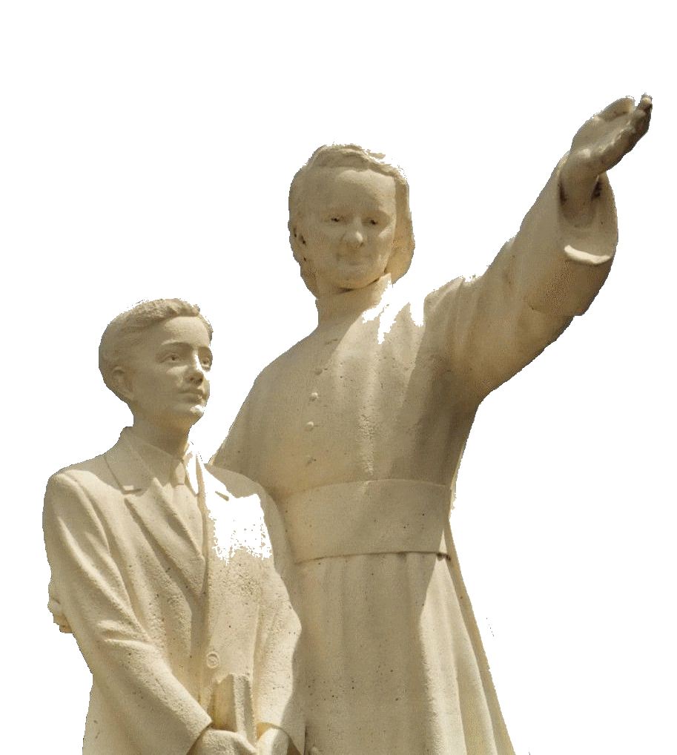

**MENNAISIAN NOVENA**

**APRIL 2025**

***Pilgrims on the* Path of Prayer**

1. **APPLICATION NEWS**

**THE CAUSE OF FATHER DE LA MENNAIS**

The whole World has recently had its eyes fixed on the A. Gemelli Hospital in Rome. This important Hospital has an International Reputation for Excellence. Many Specialist Doctors who consult with the Dicastery for the Causes of Saints practice there. For the Cause of Beatification of Our Father de la Mennais, we have two Infectious Disease Specialists from Gemelli who are preparing an Expert Report that seems to be moving in the right direction to resume the Cause of Enzo Carollo's Healing: they would like to propose other Elements that could justify a New Examination by the Official Medical Commission of the Dicastery. Let us wait, Pray, and Hope.

**OUR BROTHERS, WITNESSES OF HOPE**

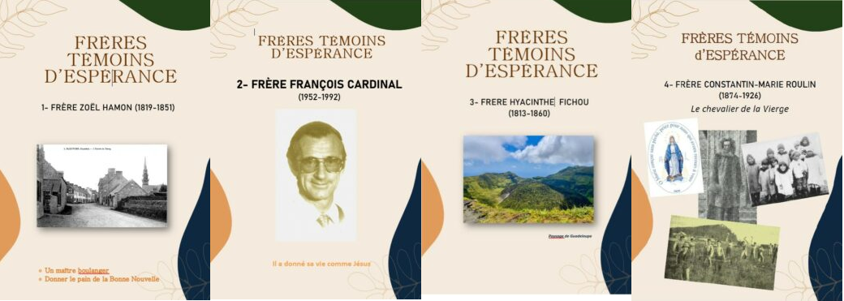In the Tradition of the Mennaisian Congregations, the Brothers who have been Splendid Witnesses of Christian virtues, especially Charity and Hope, have always been highlighted. We have prepared simple and well-illustrated booklets “LITTLE LIVES OF BROTHERS, WITNESSES OF HOPE”), which could be made available to Students, Teachers, Families and the Christian Communities. In these difficult times, these Brothers (for the moment we have the booklets of Zoel Hamon, Hyacinthe Fichou, Constantin-Marie Roulin, François Cardinal) could help us to live Our Mennaisian Vocation, with their Fiery Zeal and Iron Courage, following in the footsteps of Father de la Mennais. For a possible Introduction of their cause, we must first of all collect the signs of their Reputation for Holiness, in the places they frequented and among the people who keep their memory alive. That Research could be carried out on site and by those who belong to the Mennaisian Family: care of the Tomb and the Places, knowledge through the Distribution of Publications (on the Lamennais.org site), Invocations through their Intercession, diffusion of their benefits... All are invited to carry out that Process, in particular in the Places where those Witnesses lived.

1. **PRAYER INTENTIONS THROUGH THE INTERCESSION OF THE FATHER**

We entrust to the Intercession of Father de la Mennais:

* Several Brothers who recommended themselves to the Prayers of the Mennaisian Family, through the Intercession of Father de la Mennais; there are several who were present in the Homes of the Elderly or Sick Brothers. Reciprocally in these Houses the Brothers offered their Prayers and their Sacrifices for the good of the Mennaisian Institutes.
* Children, beloved by the Father: Tommaso and Alessandro, Alvaro (Cancer), Camilla (Coma after Accident).
* Parents: Caroline (Cancer), Massimo (Stroke)
* Mr. Stéphane, paralyzed after a Serious Motorcycle Accident
* We also recommend to the protection of the Father the three Brothers who were sent on Mission to the Island of Timor Leste (Asia): Br. Stéphane Le Pape, Br. Philippe Douti and Br. Éric Mugisa.

1. **FAVORS OBTAINED THROUGH THE INTERCESSION OF FATHER DE LA MENNAIS AMONG THE DAUGHTERS OF PROVIDENCE**

**SACO, MAINE, USA:**

*"I had been Ill for several years. Several Headaches, Back Pain, and Pain in all my Muscles at once. When I got sick, they had to take me to the Hospital. The further I went, the worse it got. So they decided to Operate on me, to better understand the Nature of my Illness. I was scared and worried a lot."*

*One of my Aunts, a person very attached to the Cause of Father de la Mennais, gave me a Relic Image of the good Father and told me not to fear and that everything would be fine. And the Operation was very Successful. Since then, I kept my Image in my Purse and always carry it with me. I commended myself to the good Father every day and regularly recite the Prayer for his Beatification. Please send me other Relic Images, so that I could make him known to other people around me.*»

*“A Daughter of Providence, suffering greatly from her Eyes, went to see an Oculist who declared that she would soon go blind if she did not accept Immediate Surgery. She had a pressure of 60 in her Eye. Returning to her Community, she made a Novena to Our Venerable Father and went back to the Oculist. The latter noted that her pressure in her Eye was only 10 and declared that she was cured. Since then, everything has been fine.*".

Mother Saint-André, Daughter of Providence

BRITTANY

"I still owe a Debt of Gratitude to the good Father de la Mennais. It concerns a person suffering from an Illness that, if not fatal, certainly required a Delicate Operation. I treated her regularly every day for two Months, during which time I never ceased to pray to the good Father to come to my aid; it soon became clear that he was protecting her. At the time when I made known two other Favors obtained through the Intercession of the Venerable, I was quite convinced that the Illness was over. I neglected to make that fact known; human respect was not unrelated to the motives that led me to do so: "Will people not believe in the long run that I see Miraculous Cures everywhere!"

*But now I had my Lesson: the Illness reappeared, worse than before; I had to pray and beg the good Father and promise to report the benefit. That time, the Illness completely disappeared.*»

Sister Saint-Ambroise, Daughter of Providence

PRACTICAL INFORMATION: Members of the General Council, during their visits to the Province, brought with them Numerous Relic Images. The Brother Animators could receive them and make a reserve to distribute to people in difficulty, who asked for Favors through the Intercession of the Father. These Relic Images contain a Small Piece of Cloth that touched the Tomb of the Father in Ploërmel. The Prayers were written in Several Languages: currently in French, Spanish, English, Indonesian and Italian.

**OUR LADY OF KIBEHO (Rwanda): A MOTHER WHO SUFFERED FOR HER SONS AND BELOVED THEM TO RETURN TO GOD**

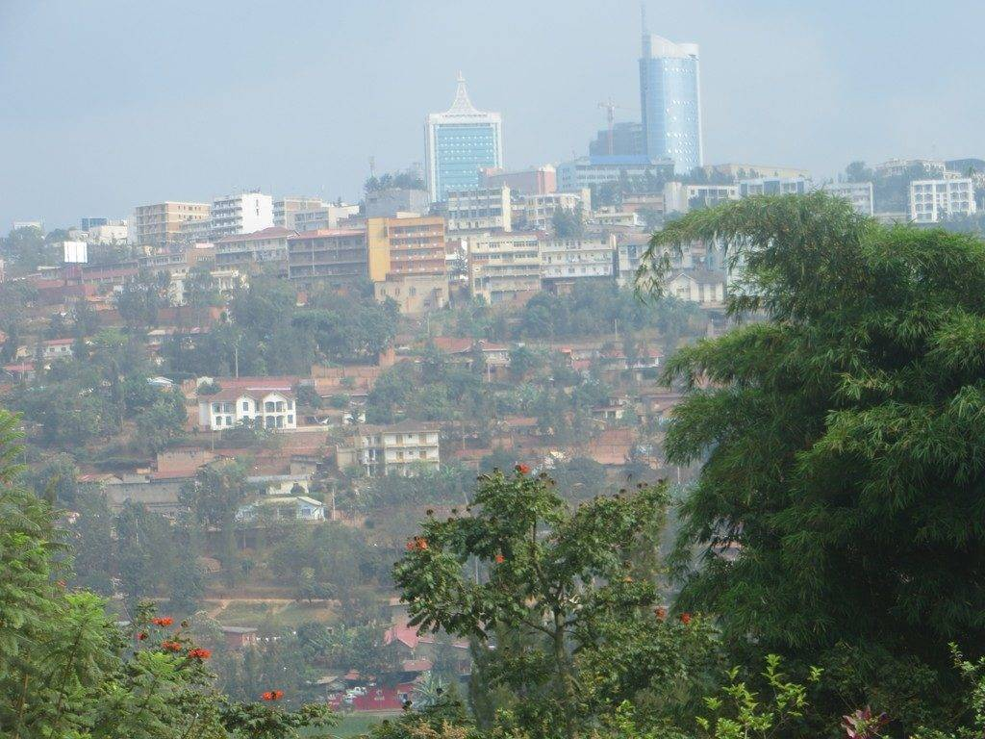**THE APPARITIONS OF THE VIRGIN MARY, 1981-1989**

The 3 clairvoyants of Kibeho

Kibeho, Rwanda

*“Yes, the Virgin Mary appeared in Kibeho on November 28th, 1981, and in the Months that followed. Only the Three Visionaries from the beginning are considered Authentic: Alphonsine Mumureke, Nathalie Mukamazimpaka, and Marie-Claire Mukanganco.”*That was the Statement of the Local Bishop, Diocese of Gikongoro, Mgr. Augustin Misago, on June 21st, 2001, after a very long and Serious Investigation carried out by the Ecclesiastical Authorities. The Apparitions of the Virgin in Kibeho were the first to have been verified on African Soil and the only ones on that Continent Officially Approved by the Church. The place chosen by the Virgin was Kibeho: a Locality located in the Southwest of Rwanda, a Small Country in the Heart of the Great Lakes Region, in Central-Eastern Africa. Rwanda was called the “Land of a Thousand Hills”: a Green Landscape, a resplendent Nature with its Lakes, Rivers, Volcanoes, Forests, Parks… In her History, however, it has been overwhelmed by very Serious Problems: Poverty and Diseases, Ethnic and Political Tensions, Armed Conflicts and Mass Displacement in neighboring Countries… The Virgin chose Kibeho to make it a Place of Prayer and Hope for Africa and the World, indicating the way of returning to God and Fraternal Reconciliation.

**THE EVENTS OF THE APPARITIONS**

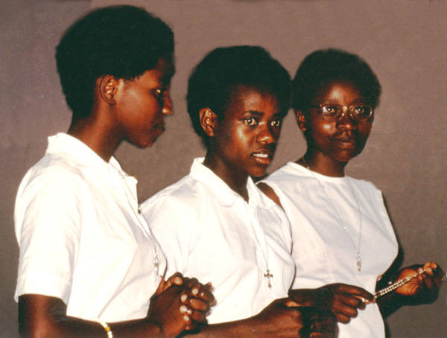The Story of the Apparitions began on November 28th, 1981, in a rather Poor Rural Religious College attended by about a hundred girls from the Region, who were studying to become Primary School Teachers or Secretaries. A young girl, Alphonsine, was serving her Classmates in the Refectory when she heard a Voice: “My Daughter, come here.” She went into the Corridor and saw a Very Beautiful Woman who said to her: “I am the Mother of the Word” (Jesus), then invited her to pray and to have her Classmates Pray. At first, the reception of the Apparitions was not favorable: Alphonsine was considered a Hysterical girl and was mocked. However, the Virgin appeared to two other girls: Nathalie, 17, a Studious and Pious Student, and Marie-Claire, 21, who had previously opposed the veracity of the Apparitions. At the College, Opinion changed, and Pilgrims began to flock there. The Beautiful Lady could give her Messages to each of the Three Seers: she gave them for two years to Nathalie and Marie-Claire, while Alphonsine would receive them until November 1989. Let us listen to some of those Messages:

* An Urgent Call to Conversion and Repentance: “The World was in Rebellion against God. Repent, Repent, Repent!”
* The Deep Sadness of the Virgin. She wept, she showed herself as the “Mother of Sorrows” and invited us to Recite the Chaplet of Sorrows of the Virgin Mary. “Pray the Rosary, especially the Sorrowful Mysteries, to receive the Grace of Repentance.”
* She suffered from the lack of Faith and Hatred among her Children: “This World was on the brink of Catastrophe. Meditate on the Immense Pain of Jesus and his Mother.”
* On August 15th, 1982, the Virgin revealed the Terrible Events of the Massacre between brothers of the Rwandan Genocide and the Countries of the Great Lakes Region, but also of all the Wars: it was a Maternal Appeal full of tears to find the path of Reconciliation, Forgiveness and Fraternity: “I have seen many of my sons lost and I have come to show them the True Path.”
* As with other Marian Apparitions, the Fundamental Message of Kibeho was Conversion of Heart, Prayer, Penance, and the ability to Suffer out of Love: “We must suffer with Jesus, Pray, and be Apostles. Follow the Gospel of my Son and put it into practice: by doing that, you would certainly be happy in Your Soul. You must make many Sacrifices to help Jesus save the World.”
* By following Mary's Maternal Invitation, as at Cana, to follow her Son, Rwanda, Africa and the Whole World would obtain much fruit: "I am happy with the fruits that have been produced since my arrival in Rwanda. Regarding the Misfortunes that were falling upon you, do not be troubled, for nothing was stronger than God himself."

Our Lady of Kibeho

* In her Last Apparition, the Virgin greeted Alphonsine: “My children, I love you, I love you very much. But do not show yourselves indifferent to that Love. I came for you because I saw that you needed it! Pray, Pray, Pray!”

The Place of the Apparitions

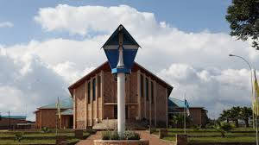The Mother of the Word, Mother of God, Mother of Sorrows (Titles that the Virgin attributed to herself in Kibeho) watched over her children, especially those who were more Distant and Suffering. “We are beginning to see the fruits of her calls: the Reconciliation of a people who have been through Genocide, a more Vibrant and Enthusiastically Expressed Faith; New Charitable Initiatives and a New Sense of Responsibility in Parish Communities; a more Personal Prayer.” (Fr. Sinayobye, Former Rector of the Shrine of Kibeho)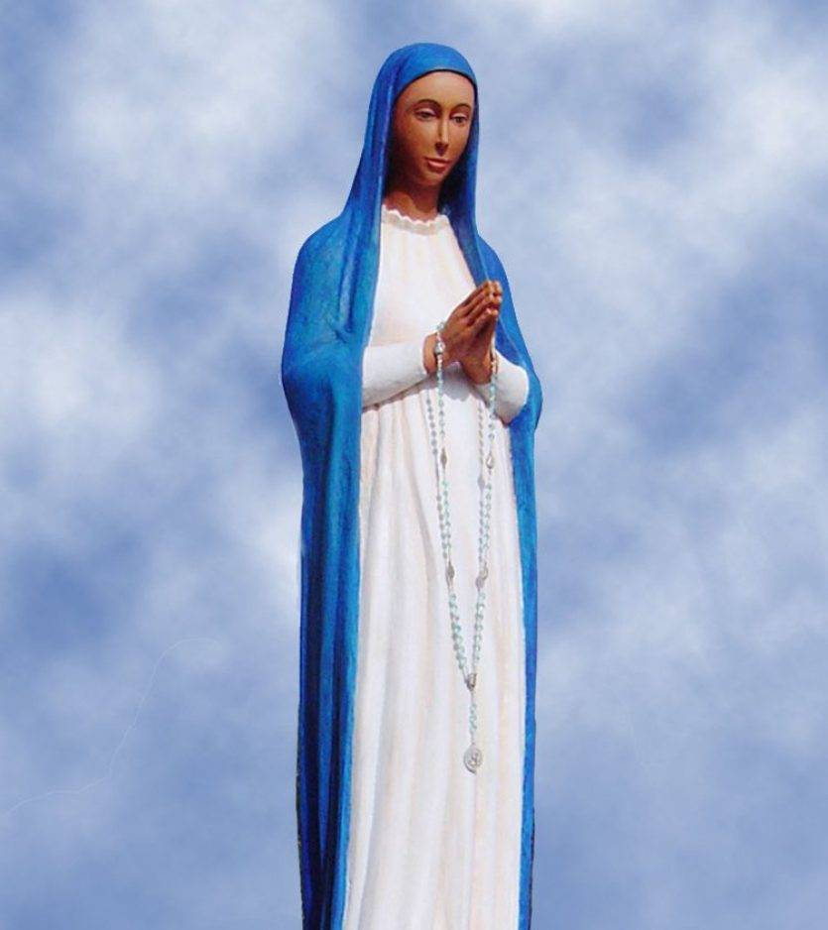

The current Bishop of Gikongoro, Mgr. Célestin Hakizimana, was firmly pursuing the development of the Kibeho Sanctuary built in 2003, which was intended to be “the Meeting Place for Seekers of God, a High Place of Conversion, Reparation for the Sin of the World and Reconciliation; a Rallying Point for those who were dispersed, as well as for those who are enamored of the values ​​of Compassion and Brotherhood without Borders.”

**THE BROTHERS OF CENTRAL AFRICA AND THE APPARITIONS OF KIBEHO**

The Provinces of the Brothers of Central Africa are currently giving Great Hope to the Congregation: they are animated by the Enthusiasm of the Young Brothers; they devote themselves to the Mennaisian Mission with Ardor; they cultivate New Projects through the fruitfulness of New Vocations; they have become Missionaries in their turn, after having received Apostolic, Spiritual, and Economic Support from the Provinces of Origin of their First Missionaries. They are making Jesus and Mary known and loved by the children and young people of their Country. At the same time, especially since the 1970s, these Provinces have suffered Political Unrest, Persecution and Intimidation, Fratricidal Conflicts, Natural Disasters… These difficulties have caused Great Pain, Abandonment of Works, Poverty and Forced Displacement, and even Victim-Martyrs. Providence has transformed these Crosses into Blessings. Let us briefly examine each of these Provinces.

1. **PROVINCE OF SAINT THERESE OF THE CHILD JESUS:**

**UGANDA AND SOUTH SUDAN**

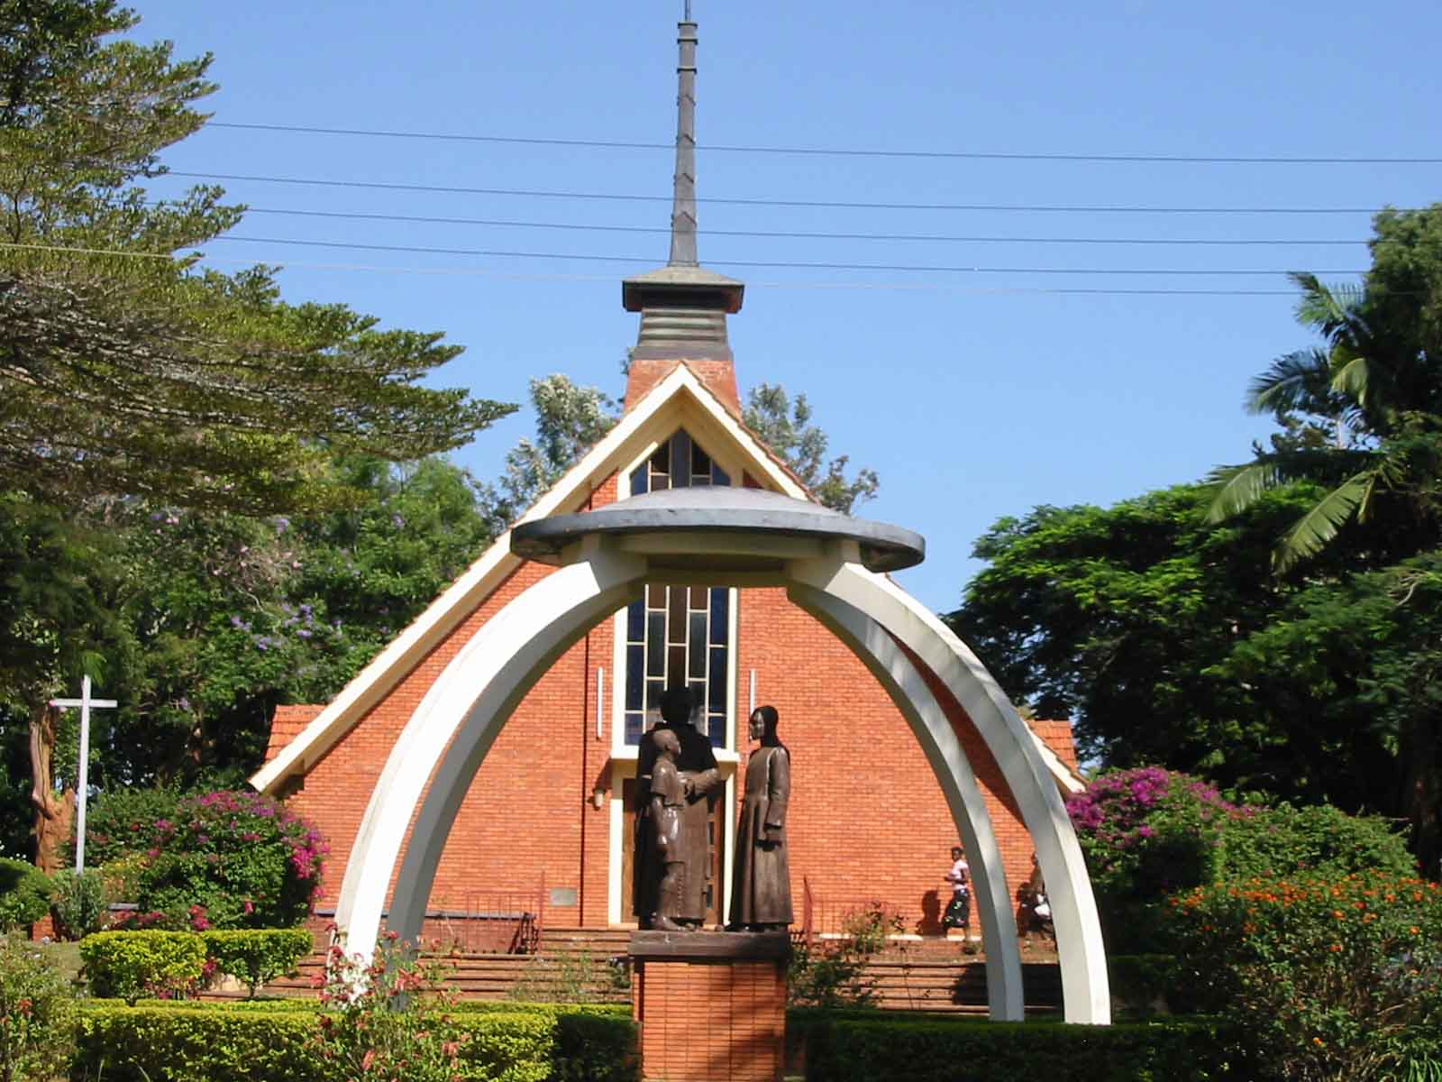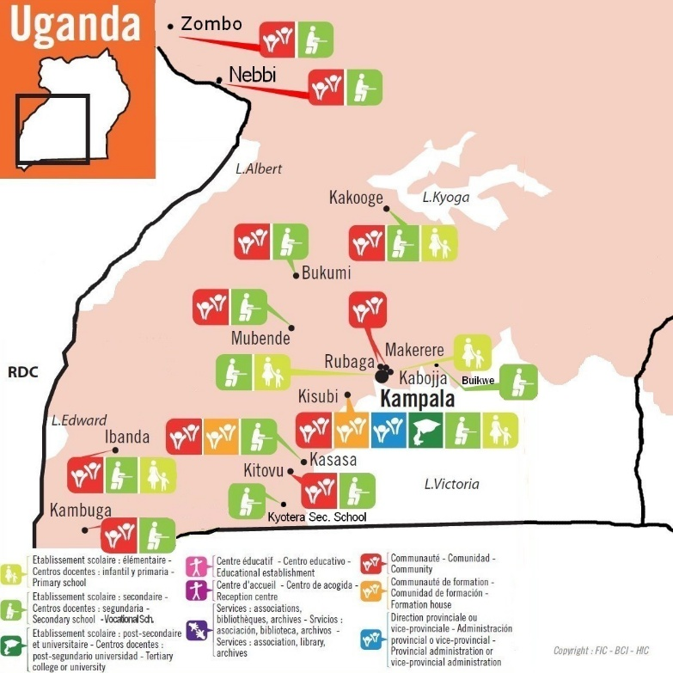Uganda is the Oldest Mission in East-Central Africa. Opened in 1926 by the Brothers from Canada, it has grown steadily, carefully cultivating Local Vocations. Kisubi has become the Heart of that beautiful Mission: it includes Formation Centers and numerous Educational Institutions. The 22 Communities in Uganda follow the zeal of the early days of Father de la Mennais's Foundations. In addition, the Ugandan Province sends Brothers to other Provinces. It also helped a Community of Local Sisters in Nebbi approach the Institute of the Daughters of Providence. That Path of growth has not always been easy: there have been Persecutions, Dictatorships, Political Conflicts, outright Wars between one Army and another, Years of Poverty, and the Scourge of AIDS. Currently, the Political Situation is more stable and the Economy is improving. Everyone hoped that stability could continue for a long time.

Kisubi Mount Saint Teresa

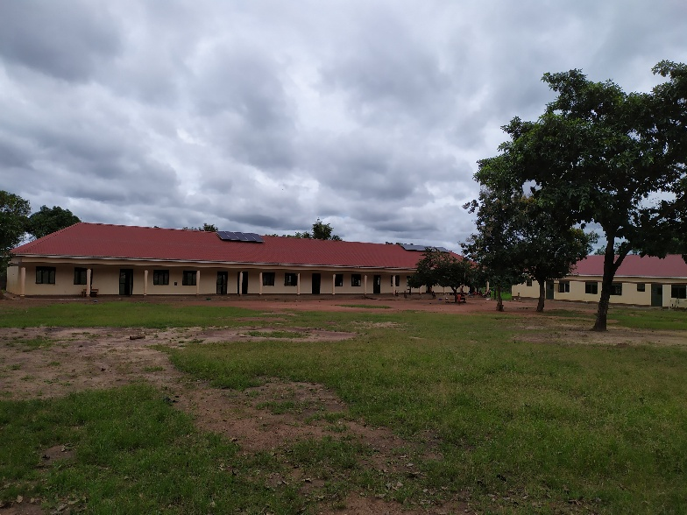The Brothers of Uganda founded a Community in Riimenze in 2013, in South Sudan, in the Heart of a relatively Poor Rural Region. Work began on building a House for the Community, in order to forge close ties with Families and the Local Population. In a second phase, construction began on the Primary School, with the support of Solidarity Associations from across the Congregation. After delays due to Political Instability, the School was able to open in 2018. Currently, Armed Conflicts also prevent Educational Activities from running smoothly, and they often have to be suspended. Nevertheless, the Brothers remain courageous, supported by the Local Community, which ensures their protection. Despite and amidst these difficulties, Mennaisian Vocations are beginning to flourish: the First South Sudanese Brother ALEX ELISAPANA made his Fist Vows in 2018 and now more Postulants have already joined the group of Ugandan Postulants in Kisubi.

Our Lady of the Assumption School in Riimenze, South Sudan

1. 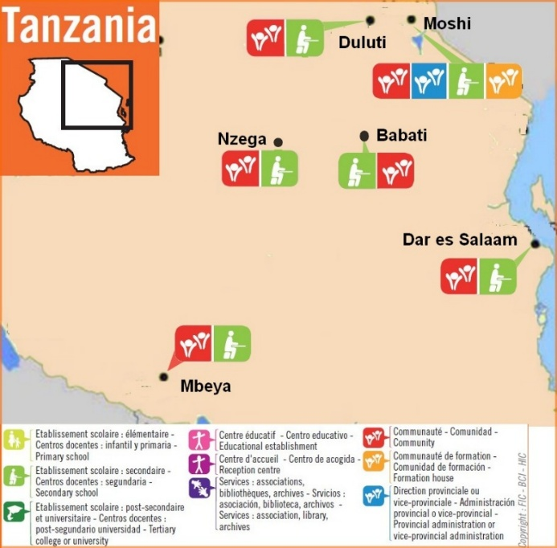**SAINT MICHAEL THE ARCHANGEL PROVINCE:**

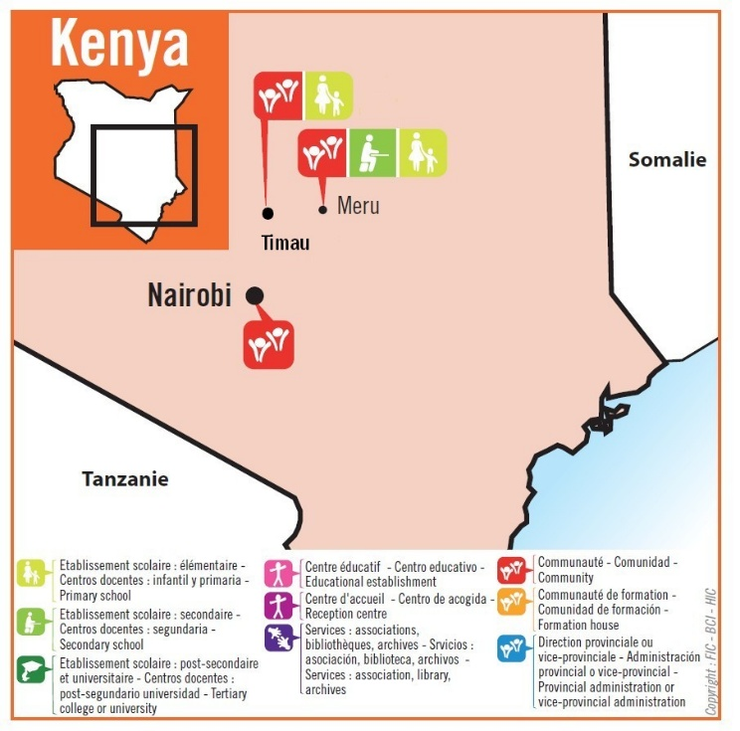**KENYA AND TANZANIA**

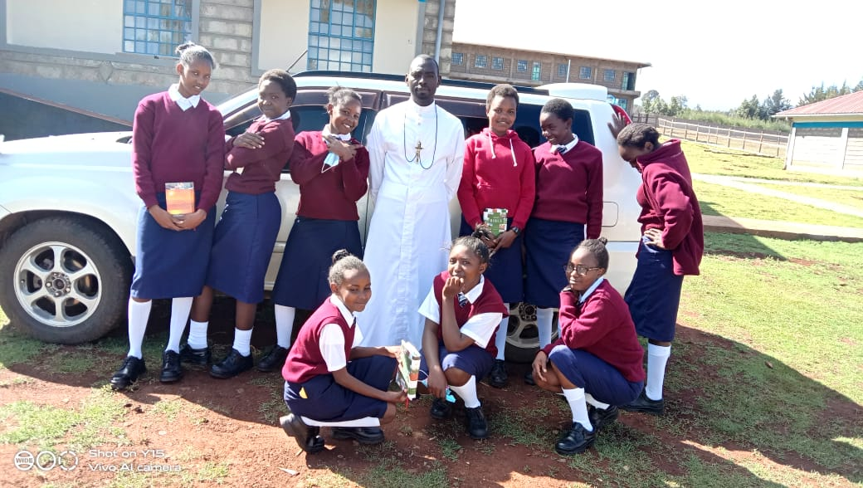Since 1931, starting with the Yala School, the Canadian Missionary Brothers had reached Kenya, then Tanzania in 1948. In KENYA, the Ugandan Brothers opened a Secondary School in Meru in 1993. Then a Residential House was Established in Nairobi and recently a Community in Timau run the St Padre Pio High School, carried out in collaboration with the Projects promoted by the ASSIFIC Association.

New School in Timau

In Tanzania, the Brothers are established in Six Communities that run Five Secondary Schools: Babati, Dar es Salaam, Duluti-Arusha, Mbeya, and Nzega. They carry out Educational Work that was particularly valuable for that young Country. The Brothers also run a Vocational Center in Moshi, where the Province's Postulancy was also established. In these two Countries, too, there have been no shortage of difficult times: War, the Forced Displacement of Masses of Refugees from neighboring Countries, Terrorism from Extremist Groups, etc. But the steady progress of the Province promises a development full of promise, under the protection of the Archangel St. Michael. Vocational succession was ensured by a growing number of Novices and Scholastics, who joined forces for their Formation with those from Uganda, in Kisubi.

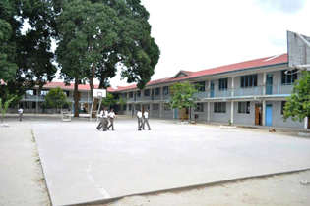

Monkey Secondary School in Babati

1. **FORMER DISTRICT OF SAINT-JEAN-PAUL-II:**

**CONGO DRC, RWANDA and BURUNDI**

At a time when the Religious and Vocational Crisis was hitting the Western Countries of Old Christianity, the Provinces of Canada sent their Missionaries to Two Countries in Central Africa, which needed special support for the Work of Evangelization, Civil Pacification and Economic Development: the Congo and Rwanda-Burundi. The First Four Canadian Brothers arrived in Congo-Zaire, in the Very Poor and Unstable Region of the Great Lakes. They were 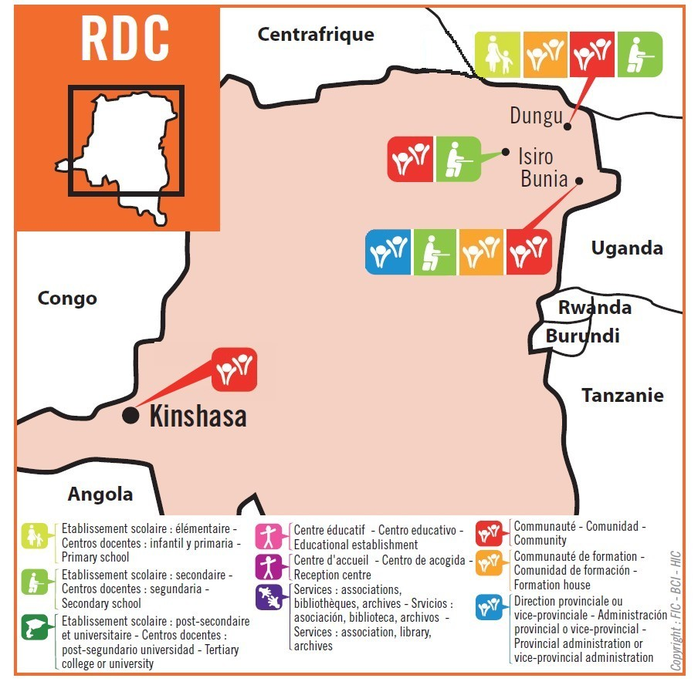 Brothers Raymond Hamelin, Richard Doyle, Albert Simard and Jean-Claude Hould. They immediately became involved in a Secondary School, the Wando Institute and in other Diocesan Works, especially in a Catechetical Training Center and also in a Professional Carpentry Center. They were very involved in the succession: in 1985 the Mission opened the Scholasticate. The Mission seemed to be well launched, but Political Events caused unrest in the Country: the Canadian Brothers had to leave the Congo; the Works were closed and monitored by the Congolese Brothers and Aspirants, who shared the tragedy of their people. It should be noted that the Brothers are established in the Northeast Region, the 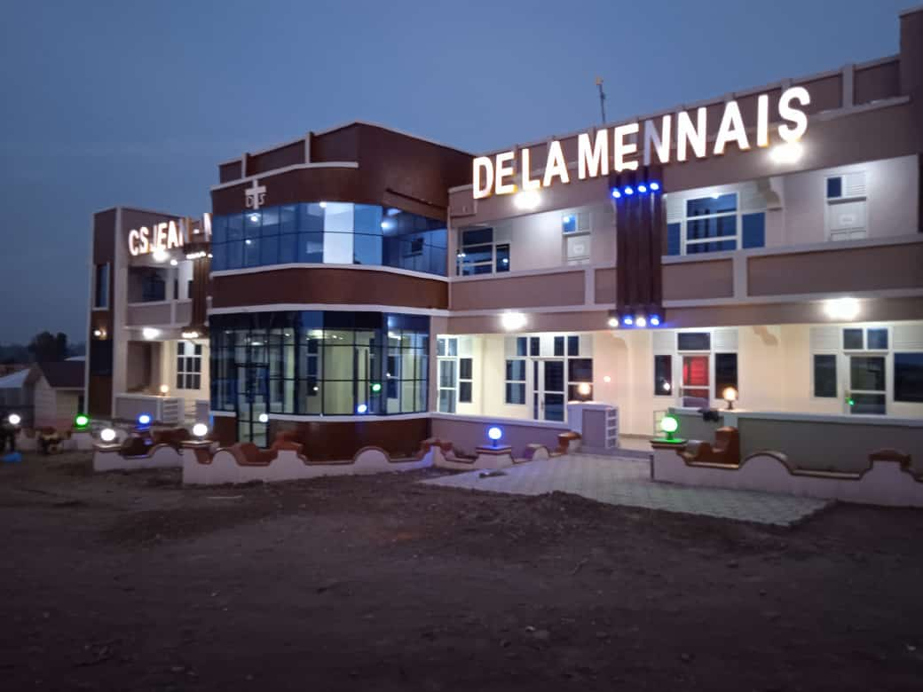

Jean-Marie de la Mennais School Complex in Bunia

most struck by Conflicts, due to the presence of Refugees, Natural Disasters, Wars for the exploitation of its Immense Natural Resources. Let us also recall the Very Serious Air Incident of February 16th, 1989, when the Small Cesna Plane piloted by Brother Normand Berger crashed into a Volcano, resulting in the death of Four Brothers – Brothers Lucien Baffaro, Normand Berger, Rémi Claveau, Robert Duchesneau (Paul-Emile) – and Two Dutch Lay Missionaries.

Fortunately, things are improving, and the Mission could resume its School and Apostolic Activities. Currently in Congo, DRC, the Brothers, all Indigenous, are present in Dungu: Wando Institute, Juniorate, and a Trades Center; in Isiro: St. Rosary Diocesan Secondary School; in Bunia: JM de la Mennais School Complex and Postulancy. In Kinshasa, a Small Community welcomes the Brothers who are Students or passing through. The Virgin Mary, who shared the Pain of her people, would certainly have shed her tears for that Country, both Splendid and Wounded; but she was also present among her sons to constantly revive their Hope against all Odds.

In 1968, the Brothers arrived in Rwanda, the Country chosen by Mary to appear - in Kibeho - to her children. The Mission began with the Most Beautiful Prospects. In Gisenyi, the First Brothers, Irénée Blouin and Gérard Parisien, took charge of the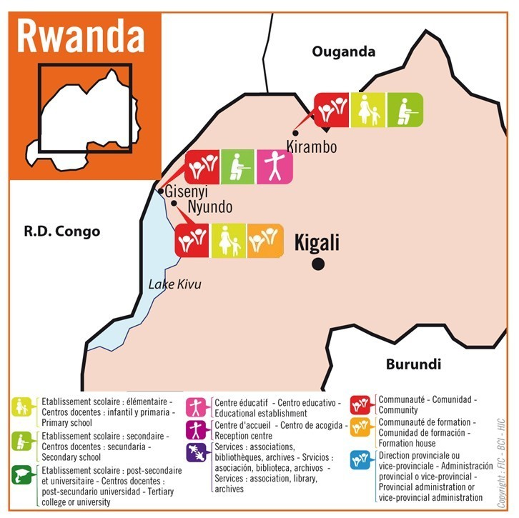 Diocesan College “Inyemeramihigo”. Other Brothers would arrive during the following years: they led the Pastoral Care and Diocesan Catechism; they developed a Field in Nyundo for Spiritual Retreats; they opened Youth Training Centers, with Agricultural, Technical, Electronical, Cultural Sections… In 1975 they settled in Rambura, in a College with an Agricultural Vocation, which developed rapidly and became an Important Secondary School with Four Options, attended by a Thousand Boarding Students. In 1990, while that College was booming, the Brothers were inexplicably 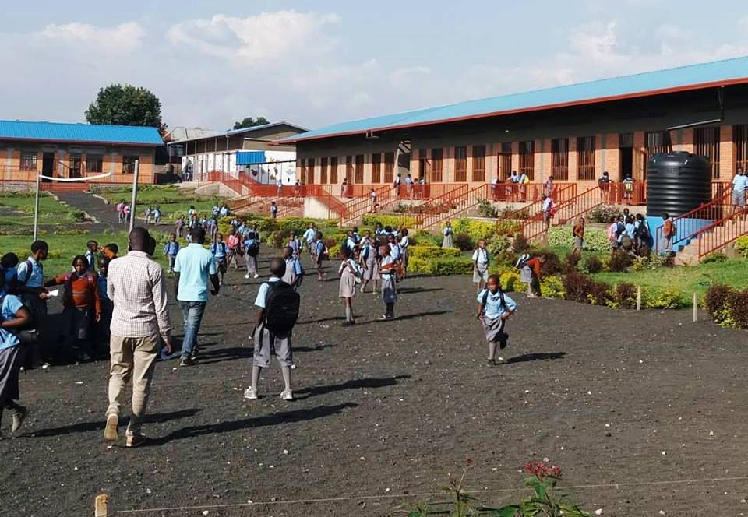expelled, because of Political Intrigues. The Distant Community did not discourage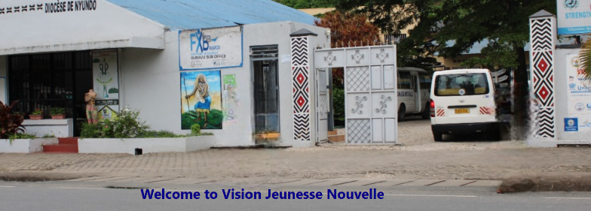 step and opened a College in Kirambo.

Saint John Paul II School of Mbugangali in Gisenyi

The Small Province had already initiated another area of ​​activity in Butamwa near Kigali: a Rural Youth Training Center, with Periodic Training Courses. For Two Months, a group of 50 young people Learned on-the-Job Cultivation and Livestock Farming Techniques, in a context of Civic and Religious Education. The Region's Farmers were also involved in that Agricultural Development: improvement of Techniques, Lending of Resources, Marketing of Products, etc. Brother François Cardinal, the driving force behind that Movement, encouraged the advancement of the Poor, welcomed all those who came forward without Ethnic Distinction, and defended the Weak against the Violence of the Powerful. On the Evening of November 29th, 1992, he was killed by a Gang of Assassins, in a murder intended to put an end to his Courageous Evangelical Witness. Shortly after, in April 1994, the Terrible Genocide broke out, with Hundreds of Thousands of Victims, as the Virgin had announced in Kibeho.

After a Temporary Withdrawal, the Canadian and Rwandan Brothers returned to Kirambo and Gisenyi. They restored the Premises of the Nyundo and Gisenyi Communities; the Kirambo School was rebuilt and expanded, becoming a Teacher Training College. The Nyundo Community now hosts the Postulancy, and in 2018 a New Primary School, “Notre Dame des Anges,” was opened near the Community. In Gisenyi, in 2015, the Jean-Paul II Nursery and Primary School was founded.

A Magnificent Work has sprung up in Rwanda. It has had an unexpected resonance and rapid growth throughout the Country: the “VISION JEUNESSE NOUVELLE” Association, founded in 2002 by Brother Gabriel Lauzon in collaboration with Father Epimaque, Parish Priest of Stella Maris Parish in Gisenyi. That Association works closely with the Diocese, State Institutions, and other Organizations. The Goal was to combat the scourge of AIDS and other Contagious Diseases, as well as Delinquency in all its Forms. VJN's Activities reached more than 20,000 Children and Young people throughout the Region. They include:

*“1- Literacy, French and English, including for the Deaf and Dumb. 2- Sports and Leisure: Football, Volleyball, Basketball, Handball, Swimming, Karate, Athletics, Kung-fu. 3- Culture: Theater, Traditional and Modern Dances, Orchestra, Library, Computers… 4- Assistance to Vulnerable People: Work Cooperatives, Apprenticeships, Microfinance, Introduction to Savings and Credit. ”*That Magnificent Work was based on the Great Suffering endured by the Rwandan people, in union with the Passion of Jesus, with the aim of projecting a New Youth in a Reconciled Country, where Peace and Fraternity Reigns.

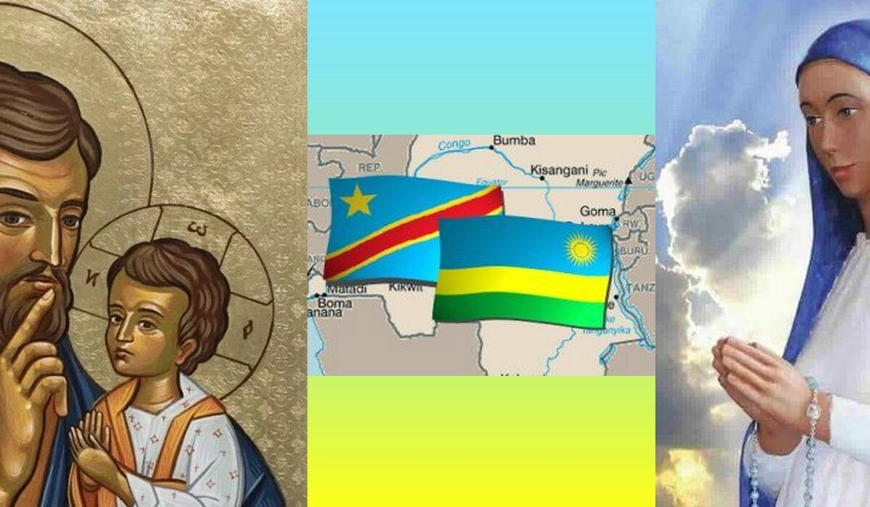Another Fruit that was ripening in that Country was the abundance of Vocations to the Consecrated Life: many young people are hearing the call to place themselves at the disposal of the Divine Master for the Material and Spiritual growth of children and young people, especially in the Institute of the Brothers of Christian Instruction. May the Virgin of Kibeho Bless that Land that she has chosen to bring her Message of Conversion and Hope.

**Currently, with a view to Greater Autonomy, the John Paul II District has been organized into Two Districts: the Saint-Joseph District consisting of Congo DRC and the Our Lady of Kibeho District, made up of Rwanda**

**NOTE ON BURUNDI:**

At the same time as in Rwanda (in 1968), the Canadian Brothers had opened a Mission in Burundi (Rutovu). Among them were Brothers Rémi Brodeur and Joseph Bourgeois. Political Unrest and Ethnic Tensions forced the Brothers to leave the Country. They tried to return around 1990 to take over the Management of the Large School in Kiryama; but the Political Situation was such that the Superiors decided to close the Burundian Mission in the year 2000.

SOURCES: LA MENNAIS.ORG: FICs around the World/FIC DIRECTORY 2024/ Br. Marcel Sylvestre and Andrew Paquin: 150th Anniversary of FIC Missionary Action/ FIC Roma ARCHIVES, Biography of Br. François Cardinal/ La Chronique FIC, October 1990, Article by René Laurentin: “Kibeho: an African Lourdes” with photos taken by a Pilgrim FIC Brother.