

**MENNAISIAN NOVENA**

**OCTOBER 2024**

1. **POSTULATION NEWS**

On October 1st, Three Specialists who studied the healing of Enzo Carollo met to give Common Conclusions. If this expertise was favourable to the Inexplicability, we would be able to see how to proceed with the Dicastery for the Causes of Saints.

At the same time, we are studying the files of some Brothers who have left important traces of “holiness”. The Brothers who are more advanced in this study are Brother Zoël Hamon and Brother François Cardinal. For the moment, the priority requirement was the collection of Testimonies of Life, but especially of the reputation of holiness among those who have known the servants of God, directly or indirectly, as well as of the Favours attributed to them.

1. **PRAYER INTENTIONS**

We continue to pray for Our Little Ones: Tommaso, 6 years old, the continued improvement of the Digestive System; Alessandro, 8 years old, Advanced Cancer with Metastases; Greta, 9 years old who has become an Angel of Heaven. Let us also pray for Our Sick Brothers, especially for Brother Alain Josselin who underwent a New Major Operation on October 13th . A Recommendation to the Father also for Inès Kato, cousin of Br Steven: Operation on the Head and for Liliana who survives to the surprise of the Doctors. A prayer so that the Lord welcomes Mrs Caroline Gayiya, sister of Br Gérard Byaruhanga, into His Kingdom of Paradise.

1. **FAVORS OBTAINED THANKS TO THE INTERCESSION OF Fr. DE LA MENNAIS (Collection of Br. Jean-Charles Bertrand)**

*“My sister-in-law had been seized by Violent Nervous Attacks and reduced to such a painful state that she had to be sent to the Hospital. The Nursing Sisters and the Doctors declared that there was hope of saving her, but that she could hardly recover for several Months. During my visit to Montreal, I gave her a picture with the Relic of Our Venerable Father. I promised her that we would begin a Novena with the Juniors, on my return to Plattsburgh. The Novena was completed, the favour requested was obtained. Sometime later, I received the following lines from my brother: “Concerning the Recovery of my wife, I was still waiting in order to be able to see more clearly that there would be no trace of her illness. I could now assure you that she is absolutely well, just as before. I cannot obtain the Doctor's Certificate, but his own words are these: "These Cases never Recover for six or seven months, and often the Disease lasts a year." The Sisters at the Hospital told me the same thing.*

*Later, my brother again requested prayers from the Venerable Father de la Mennais for the success of an Operation deemed necessary by the Doctors. We made New Requests to the Venerable Father who deigned to listen to Our Prayers again and answer them with Paternal Kindness. My brother hastened to write me these few words: “I am happy to bring you Good News about my dear wife. She was better and would not go to the Hospital. I believe there was something Mysterious if not Miraculous in this case. She has been feeling very well for several weeks, without having followed any Treatment.*

*“Thanks to the Venerable for the help he has given us. I hope that this good will continue.”*

*If these stories are not certain to be considered Miracles, they are nonetheless to the Honour and Glory of Our Venerable Father, and deserve, I believe, to be counted among the Favours which are of a nature to increase confidence in him. I had promised him to make these facts known to him; that is why, my TRF, I have allowed myself to speak to you about them today.*

Brother Simplice (Canada, undated)

1. **TRACES OF SANCTITY AMONG THE FIC: Br. URBAIN (FRANÇOIS –JACQUES CLÉRICE): 1802- 1880:**

**A LITTLE BROTHER FROM HEROIC TIMES: FAME OF HOLINESS**

*“Brother Urbain was one of those Heroes of Self-denial, in whom Our Venerable Father knew how to instill his Fiery Zeal and Iron Courage; Heroes who dispense themselves until their strength was exhausted and joyfully, despite the often-unfavourable conditions in which they had to exercise their Painful Apostolate.” (The unspecified quotes are taken from La Chronique n.8, 1881)* In the History of the Establishment of Hénanbihen (Cotes-d'Armor,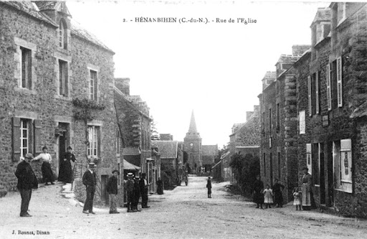

**Hénanbihen - Cotes-d'Armor**

Brittany) it was presented in this way: “The First Brother arrived in Hénanbihen in 1828 called by the Rector JM de la Fresnaye and by the Mayor M. de Floyd. I do not know the name of the First Brother. One of the First was Br. Urbain (François Clérice) of St-Brandan; he spent 33 or 34 years there; he taught under the Crypt of the Old Church, under the Sacristy, a Damp, Poorly Lit and Unhygienic Place. He left the reputation of a Religious Saint and An Excellent Teacher. He died in Ploërmel in the ordo of Sanctity. Lastly, he fulfilled the functions of Postman between the Post Office and the Community” (FIC R Archives).

**ORIGINS AND CHILDHOOD**

François-Jacques Clérice was born in St-Brandan-Plaintel, Diocese of St-Brieuc, a Breton land of Farmers and Christians, on July 15th, 1802. During the Revolution, the Population, having strong Christian Traditions, had fought against the Anti-Ecclesiastical Impositions of the Revolutionary Government. The Rector, Father François Cormaux, although very close to the people, had been guillotined. The faithful did not follow the Sworn Priests; on the contrary, they participated in Clandestine Meetings of Priests faithful to the Church, organized Night Processions to the Sanctuaries with thousands of participants and gave refuge to Refractory Priests. Some of them had also engaged in Armed Resistance, to the point of actively joining the organized “Chouannerie”.

The Clérice Family was one of those Solidly Christian Families who had educated their eight children according to the Fervent Religious Traditions and Fidelity to Jesus in the Catholic Church. In their work, as was traditional in the Region, they devoted themselves mainly to the Cultivation of Flax and its transformation into Fabric. Wheat was also grown, which explained the presence of many Bakeries.

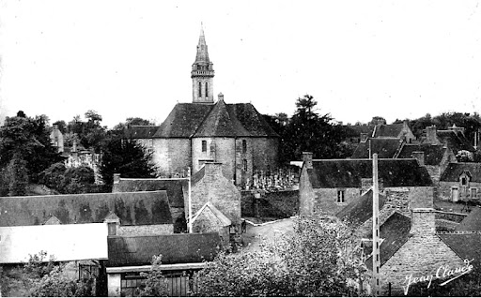

**St-Brandan-Plaintel**

We know very little about the childhood of the young Francis. [“His Biographer Epiphane-Marie offered us more Sermons than Facts,” complained the Brothers of the Institute]. He learned his Prayers at home and in Church: in his childhood he was lucky to live in a period of Relative Religious Freedom, after the Revolutionary Turmoil. He knew the Diocesan Catechism by heart at the age of 9 and at 10 when he received his Solemn Communion. He made the decision to make Confession and receive Communion every Month, as well as to regularly attend Church Services on Feast Days. He also cultivated a tender Devotion to the Blessed Virgin, nourished by the Daily recitation of the Rosary with his family. One of his characteristics that has been passed down to us was his Franciscan love of Creatures, fostered by a somewhat wild but splendid Environment: The Chaos of Gouet, the Forest of Lorge, the Well-ordered Fields... “The sight of a Flower, the Song of Birds, the Murmur of the Stream, the Countryside covered with Greenery and Harvests, joined the Magnificence of the Heavens to tell him of the Glory of the Creator.”

Our Biographer told us that “he attended the School of the Brothers of Plaintel for a few years”. We knew that the School of Plaintel was founded in 1830 (Friot EM 18, p.77) by Brother Emmanuel (Pierre Aubry). It was therefore not possible that little François attended it. But he certainly attended School: he did his Novitiate in 1827 and after only one year he was already a Teacher. We could make hypotheses: in Plaintel there was a College-Orphanage of the Sisters of Wisdom whose Superior General was Our Co-Founder, Father Gabriel Deshayes): did he receive Primary Education here as a day pupil? Or another explanation. In Quintin, a Town bordering St-Brandan, the Brothers of Mennais had opened a Large School Establishment in 1822. The Director was a very young Brother, who would make the History of the Institute through his great value as a Religious and Educator: Brother Laurent Haudry (1801-1876). In addition to directing the School, he had opened a Branch of the Central Novitiate in Ploërmel: he welcomed young people from the surrounding area, aspiring to the Life of the Brothers, with a view to giving them an Initial Religious and Pedagogical Formation and sending them to Ploërmel for the Canonical Year of the Novitiate. Father de la Mennais, who had great confidence in Brother Laurent, often passed through Quintin and each time he brought back with him some of these Candidates for the Novitiate, “and sometimes five, six at a time!” Perhaps the young François would have taken advantage of this opportunity offered by Brother Laurent to perfect his studies and prepare his journey to Ploërmel.

In any case, François, on July 16th, 1827, at the age of 25, entered the Novitiate of the Brothers of Christian Instruction in Ploërmel, where he received the name of Brother Urbain. It was a well-considered decision, given his age. He was fortunate to have a very young but particularly Fervent Novice Master: Brother Antonin Tuloup. He would take part in the Brothers' First Missionary Expedition to the Antilles in 1838 as Director General. He would soon catch Yellow Fever and would be the First Brother to die in the Colonies. In Brother Urbain's Novitiate Group there were about forty very Fervent Novices (among others Brothers Ephrem D'Equesne, Dosithée Tuloup,and Eutrope Le Vacher, who remained in the Annals of the Institute). In addition to taking care of his Religious Training, Br. Urbain “returned to his studies with all the application of which he was capable.”

**BROTHER TEACHER IN HÉNANBIHEN (COTES D'ARMOR)**

At the end of his Novitiate, in 1828, Brother Urbain was placed in the Important Commune of Henanbihen. He was, in practice, its First Teacher. The Master was full of zeal, the children ardently desired to learn, but the School was not ready. There was an Old Chapel, below the Sacristy of the Parish Church of St. Nicholas and St. William, formerly dedicated to St. Margaret. It was “a kind of Ossuary, a Half-underground Vault surrounded by Tombs, which occupied an area of ​​22.80 m²;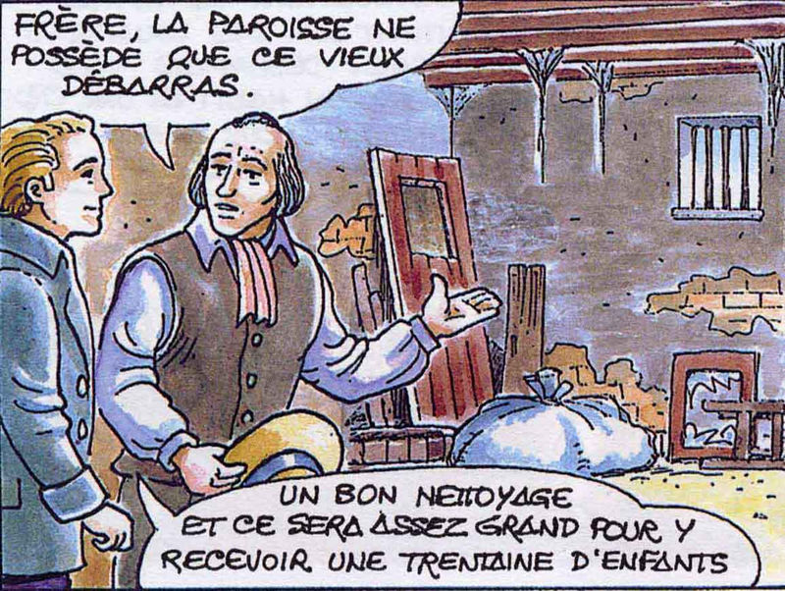*the height under the beams was 2.10 m. The Air and the Sun only reached it through a Door and Two Small Windows. To stay a year in such a Sepulchre seems a very harsh, very repulsive thing; our admirable Brother spent 18 years there [the New School began to be built in 1846], without being heard to express the slightest complaint.”* This presentation by the Biographer was not exaggerated. Father de la Mennais, who had accepted this Initial Situation, continually pressed the Administration “to provide a more Suitable House for the School, if it wanted to keep a Brother: it was time to get out of the kind of cellar in which you have been vegetating so sadly for so many years.” (Letter from the Father 22-10-1842) “It was impossible for things to remain in the state they were in: you need Larger Premises.” (1843) “Whether we rent a House or Build, it was still desirable that you get out of your hole […] the Master and the Children are too bad there!” (1844)

Yet the number of students did not decrease. They filled this “Infected Redoubt” to 120-130. At the cost of enormous fatigue, Brother Urbain held his Class Morning and Afternoon with competence and passion. He prepared the Catechism in a special way and transmitted it with fervour to the students. He led them in Parish Ceremonies, especially on Liturgical Feasts. The Founder kept telling him to reduce the number of students, to force the Administration to find Suitable Premises, following the protests of the Parents of the children who had been sent away. But Brother Urbain would never have rejected a child, nor would the children have abandoned him. Despite these painful difficulties, “the Lord blessed his Courage and Zeal: he obtained an Honourable Mention in 1855 for his Teaching and the Good Conduct of his Class.”

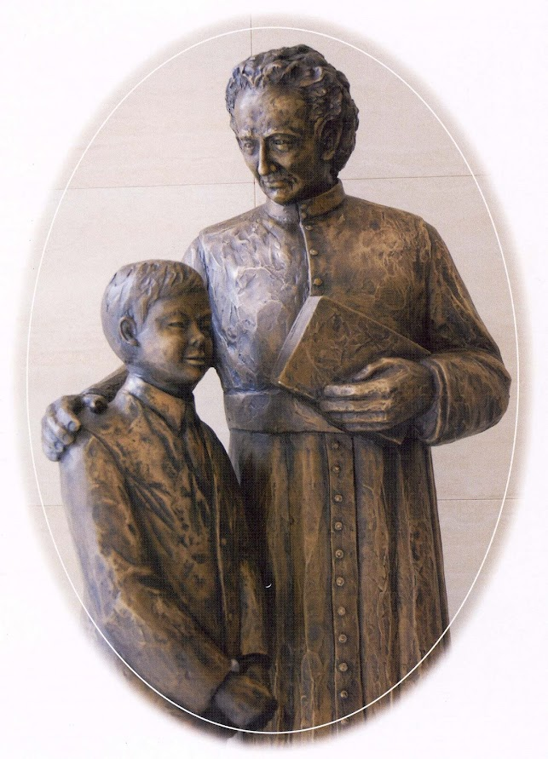After leaving his Class, he went straight to Church, where he “Refreshed his Soul” by expressing his trust in Jesus through the Traditional Devotions of Eucharistic Adoration. He usually repeated the Stations of the Cross three times a Week. After this time of prayer, he locked himself in his little Room in the Presbytery to prepare Lessons and Homework and to perfect his “Instruction in the Human Sciences”. Like all the “Brothers placed alone”, he lodged with the Rector of the Parish. He had great respect for him. Once he had fallen ill, Brother Urbain took care of him like a son and watched over him day and night. The Father praised him and reproached him at the same time: “To spend seven nights in a row giving care was too much; in such a case do not do that, because your health would suffer too much.” At the beginning there had been difficulties with the New Rector. [The Room below the Sacristy was disturbing the Course of the Celebrations]. Thanks to the patience of Brother Urbain, the solution was immediately found: “I see that everything was going well and that you have much to praise for the behaviour of the Rector towards you: I have no doubt that this would continue.” (Letter from the Father)

**SMALL SPIRITUAL PORTRAIT**

Our Brother spent 35 years in Henanbihen. There he practiced Heroic Virtues under the guise of a Common and Ordinary life. He was very simple and humble and at the same time he had good relations with everyone: “Gentleness and Indulgence were the basis of his character.” In the History of the School of Henanbihen it was noted that Brother Urbain was the Ractor of the Community. Certainly, he was well accepted by all and for him this service, somewhat singular, was a way of approaching people and doing a little good to all.

*“He was consumed with zeal for the Glory of God.”* He had asked to be sent to the Antilles, with the First Missionaries - among others his Former Novice Master, Br. Antonin, but his Mission was to remain in Brittany. “He spent Sundays and Thursday’s Teaching Catechism to children who could not read or attend School. Then he would visit the sick in the Parish and preferably the Poorest. For many years he went every fortnight more than 5 km to see an Unfortunate Bedridden Person, to talk to him about the Good Lord, the Joys of Heaven and to give him some Spiritual Readings.”

His prayer was well known to all. When he prayed, he seemed transfigured. He often went to Church: alone or with the children, on Ordinary days and on Feast days, for Silent Prayer or Popular Devotions. “On days off, if it rained, he would repeatedly do the Stations of the Cross and recite the Rosary for the Conversion of Sinners and the Souls in Purgatory.”

Br. Urbain was one of the many “Brothers placed alone” in the Rural Villages of Brittany, who relied on the Rector of the Parish. He was alone, but he was not solitary. When he could, he went to visit his Confreres in the neighbourhood. These were Meetings of Joy and Mutual Encouragement. “His conversation was always edifying and charitable; he found a way to make it focus on the things of God and on how to make children love Virtue.” He spent moments of Paradise during the Retreat at Ploërmel: there he could meet his Confreres, especially his old friends. He also liked to confide with the Father, whose letters he jealously guarded.

Everyone respected Br. Urbain, both in Hénanbihen and in the surrounding area. M. Kersanté, the Priest of the neighbouring Town of Matignon, made the strongest demands to persuade him to take over the Management of his Parish School. The humble Brother replied: “God wants me in Hénanbihen, since my Superiors sent me there: I will stay there as long as they please.” His former students remembered him fondly. Thanks to him, the Population of Hénanbihen remained very attached to the Brothers for the period they were there and even much longer. After his death, his memory had not faded. “All the fathers of families published his praises: what immense good he did in Hénanbihen!”

**IN PENGUILLY, TO HEROISM**

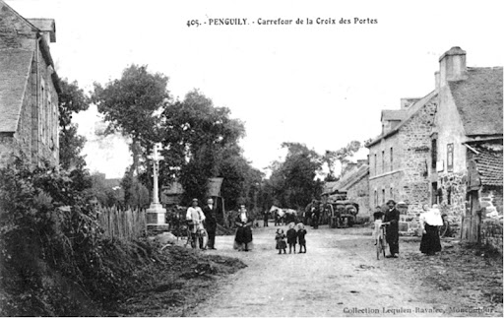

**Penguily - Cotes d'Armor**

In 1863, Br. Urbain was 61 years old and his strength was beginning to fail. The Superiors thought it appropriate to assign him the Director of a smaller School. He was sent to Penguily (formerly Penguilly), a village, then of about 600 Inhabitants, still located in the Cotes-d'Armor. It took him little time to make himself appreciated for his Educational Competence, his Apostolic Zeal, Good Relations with the Rector and the Population. An Episode would shed light on his Extreme Generosity in that period, at which otherwise would have remained rather obscure.

*“One day [in 1869] he injured the Index Finger of his right hand while closing a Door. Resisting the pain, he ignored this accident; but soon a terrible whitlow occurred, then gangrene. He was forced to go to the Mother House in Ploërmel. After consulting Doctor Pringuet, Amputation of the diseased Finger was deemed essential. Brother Urbain faced that Operation with courage, without wanting to be Chloroformed.* However painful it was*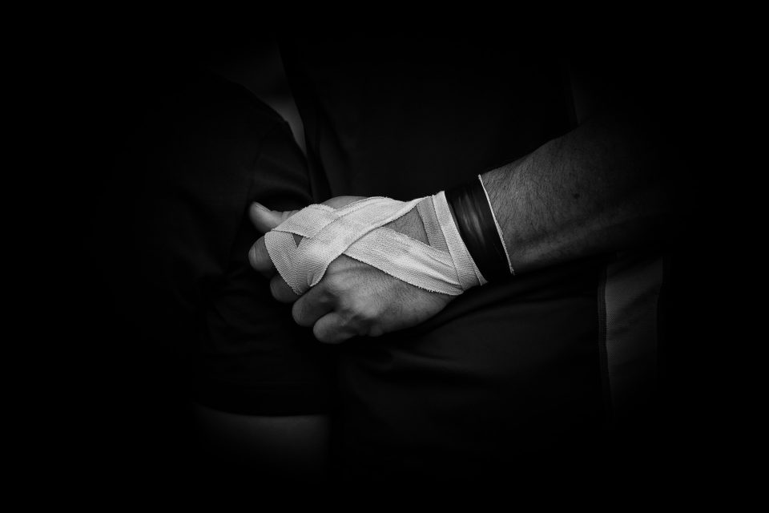necessarily the Amputation, not a single complaint escaped the patient, who united his suffering with that of Jesus on Calvary. “Never,” say Our Nursing Brothers, “had we seen the good Brother more content, more cheerful.”* Nevertheless, he was very hesitant to resume his Post at Penguily: “he no longer felt capable of fulfilling his Mission, being especially inconvenienced in doing the Paperwork because of the loss of his finger.” A notable local Benefactor, Mr. Le Bel, who greatly appreciated Brother Urbain, offered him his help, as did the Vicar and the Nuns. Everything was done to make the School more comfortable; they were also willing to give him some time to wait for the resumption: so many signs of affection from the people of Penguily towards him. “We very much want to keep him. I like to believe that Brother Urbain would not regret coming to us, but he was asking for his Retirement for fear of no longer fulfilling his duty well enough.” (Mr. Le Bel)

It was the Brother himself who would solve the problem. As soon as possible, he hurried back to his Post, where he tried to make up for the time he thought he had lost at the Ploërmel Infirmary. He did not want to be a burden to the charitable people who would like to help him and “preferred to work part of the night. His School, initially small in number, ended up comprising, thanks to his zeal, 80 students. His strengths *were exhausted, he experiences weaknesses in the evening and yet the next day, from four o'clock he would be up, for Morning Prayers and preparing the Class. Then all day with students the. At five o'clock, rest in Prayer, Study, and Works of Charity: what a life of devotion and piousness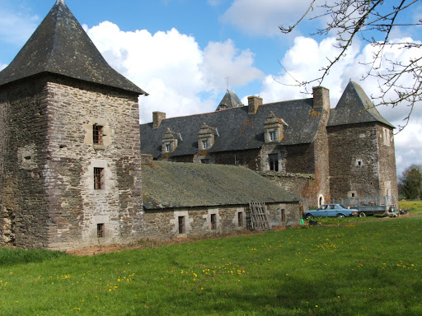self-denial!”*

**Boyac Manor**

**Manor of Boyac**

For Brother Urbain, the time of Retirement also came: “when an advanced age made him incapable of supporting the fatigues of a Class, he would live out his old age in Boyac (sic)”., In the surroundings of Ploërmel, there was the old manor of Boyac. The Founder had bought it in 1826, with the surrounding land, to make it a Country House for young people in training and with a view to a future Agricultural School. The Manor had been restored, a Chapel had been built there, and the land was worked for the needs of the Mother House. In consideration of his age (he was over 70 years old) Brother Urbain was responsible for supervising the work. “Instead of being content with supervising the exploitation, he would be the First and the Last to Work, the last to take his rest. If there was hard work, it would be for him”.

Having returned definitively to the Mother House, he asked for and obtained a Job that suited his strength, which he continued “until the tenth day before his death.” He fell asleep in the sleep of the just in the Infirmary, after having received the comfort of the Sacraments of the Dying. “One more link was added to that long chain of Religious Saints that Our Institute has produced. They spent their lives Teaching the children of the people, with the Rudiments of Profane Science, the Holy Way that led to Eternal Happiness.”

*-------------------------------------------------- -------------------*

**SOURCES: CHRONIQUE 3, 1881, pp.173-180 (F. Epiphane-Marie Guillaume, who knew F. Urbain for 27 years) / MENOLOGE: F. Urbain Clérice, pp.55-56/ THROUGH THE CORRESPONDENCE OF JM DL MENNAIS: 17 letters, pp. 212-224/ FRIOT: The Institute of FIC 1825-30 and 1830-48/ LAUNAY: F. Laurent Haudry/ ARCHIVES FIC ROME. Carton France: Henanbihen- Penguily**